LESSON 126
What is Genomics?
Genome: Total amount of DNA of a single cell of an organism (haploid cell in the case of a diploid) is called as genome. The whole hereditary information of an organism encoded by DNA is called as genome. Determination of entire genome sequence is a prerequisite to understand the complete biology of an organism. Genomics include generating physical, genetic, and sequencing maps of different genomes. It also includes sequencing the genomes of model organisms and developing new technologies for mapping/sequencing. Genomics helps in different ways such as in Functions of genes, Organizations of genomes, Structural make-up of genomes, Functions of coding and non-coding DNA. Study of Genomics helps to understand the ethical, social, and legal issues and challenges posted by genomic information.
Genomics Sub-disciplines
- Comparative genomics
- Structural genomics
- Functional genomics
- Population genomics
- Metagenomics
- Microbial genomics

LESSON 127
Functional Genomics includes Functions of genes, their regulation and end products. Functional genomics analyzes all genes in genomes to determine their functions and their gene control and expression. Classically, genetics analysis begins with a phenotype and moves for identification of genes. New approaches are needed to work in the opposite direction, from genes to phenotype.
Functional Genomics relies on Molecular Biology, Biochemistry, Genetics and Bioinformatics tools: Functional genomics relies on molecular biology lab research and sophisticated computer analysis by bioinformatics tools. Fusion of biology with maths and computer science is used for many things. Examples: Finding genes within a genomic sequence. Aligning DNA/proteins sequences.
Functional Genomics includes following
- Subtracted cDNA libraries
- Differential display
- Representational difference analysis
- Suppression subtractive hybridization
- cDNA Microarrays
- Serial analysis of gene expression
- 2-D Gel electrophoresis
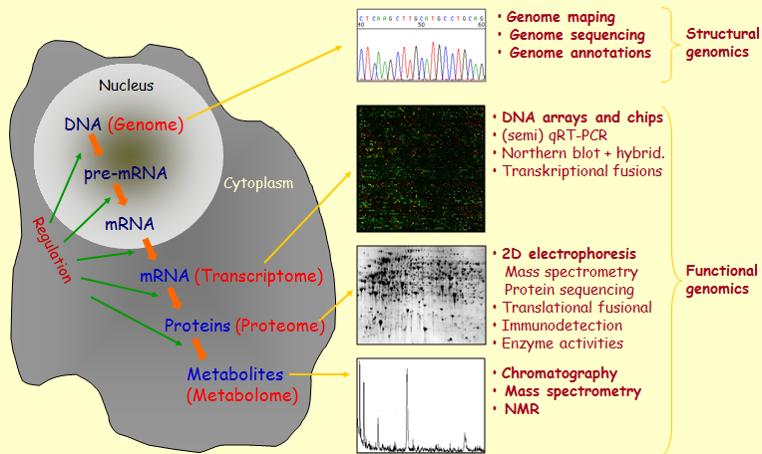

LESSON 128
Structural Genomics: The ultimate goal of genomic studies is to determine the nucleotides sequences of entire genomes of organisms. It also includes the genetic and physical mapping and sequencing of chromosomes.
Genetic Mapping: This includes approximate locations of genes, relative to the locations of other genes, based on the rates of recombination.
Physical Mapping is based on the direct analysis of DNA. Physical mapping places genes on the genomes in relation to distances measured in bp, kbp, and mbp.
Structural Genomics: these include
Distinct components of genomes
Abundance and complexity of mRNA
Genome sequences
Gene numbers
Coding and non-coding DNA
Structural Genomics – Complex Genomes have roughly 10x to 30x more DNA than is required to encode all the RNAs or proteins in the organism
Structure of Complex Genomes: This consist of following
Introns in genes
Regulatory elements of genes
Multiple copies of genes, including pseudogenes
Intergenic sequences
Interspersed repeats

Structural Genomics – Transposable Elements
Vast majority of TEs can be classified into four families:
LINEs (Long Interspersed Nuclear Elements, autonomous)
SINEs (Short Interspersed Nuclear Elements, use LINE proteins for life cycle)
LTR elements (Long Terminal Repeats; derived from retroviruses)
DNA transposons (replicate without RNA intermediary

Structural Genomics – Repetitive DNA in Humans
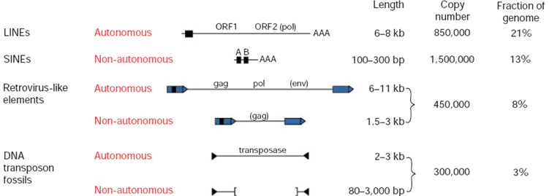

LESSON 129
Comparative Genomics: This can be defined as comparison of gene numbers, gene locations and biological functions of genes, in the genomes of different organisms. This also includes to identify and compare groups of genes that plays a unique biological role in different organisms
Homology is the relationship of any two characters (genes or proteins) that have descended, usually through divergence, from a common ancestor/ ancestral character.
Homologues are thus components or characters (such as genes/proteins with similar sequences) that can be attributed to a common ancestor of the two organisms during evolution.
Homologues can be Orthologues, Paralogues, Xenologues, Analogues
Orthologues are homologues that have evolved from a common ancestral gene by speciation. They usually have similar functions
Paralogues are homologues that are related or produced by duplication within a genome followed by subsequent divergence. They often have different functions.
Xenologues are homologous that are related by an interspecies (horizontal transfer) of the genetic material for one of the homologues. The functions of the xenologues are quite often similar.
Analogues are non-homologues genes/proteins that have descended convergently from an unrelated ancestor. Analogues have similar function, different sequence or structure

LESSON 130
Population Genomics: Study of genomes of a specific population, strains, varieties or organisms is called as population genetics. This is the study about the genetic diversity. It includes understanding new insights into disease and drug response with deeper insights about genomic size and further complexities in the genomes of the organisms. So this is the variations between individuals or strains. Human genome is 200 times larger than yeast but 200 times smaller than Amoeba. Less than 2% of human genome is coding sequence.
The 1000 Genomes - Population Genomics International research consortium sequenced the genomes of at least 1000 people from around the world. Detailed and medically useful pictures of human genome variations. Any two humans are more than 99% identical at genetic level. Genetic variations may explain individual differences in susceptibility to diseases, responses to drugs.
HapMap Project - Population Genomics: The HapMap project has already discovered many regions of the genome containing genetic variations associated with common human diseases.
Goals of Population Genomics: Followings are the goals of population genomics such as to Produce a catalog of variants present at 1% or greater frequency in the human population. Down to 0.5 percent or lower within genes. Increase sensitivity of disease discovery Provide better understanding of very rare genetic diseases. Understand contribution of common variants to common diseases like diabetes and heart diseases. Identify SNP but also large differences like rearrangements, deletions or duplications

LESSON 131
Metagenomics Metagenome - Environmental genome: This can be defined as collection of genes sequenced from the environment could be analyzed in a way analogous to the study of a single genome.
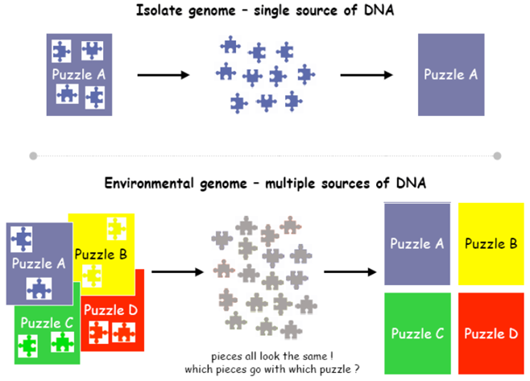

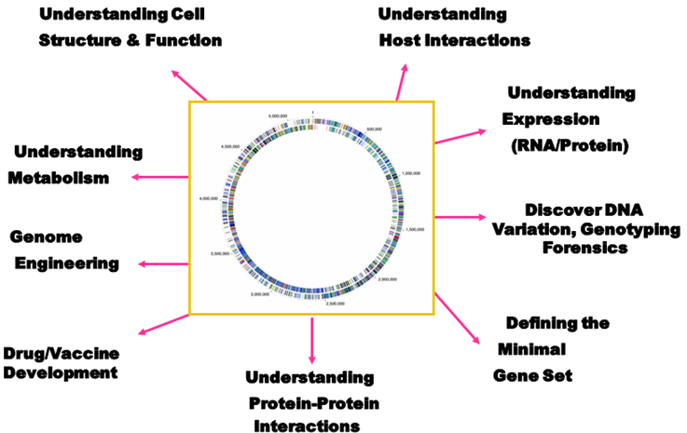

Objectives of Metagenomics: Followings are the objectives of metagenomics
- Examining phylogenetic diversity using 16s rRNA
- Diversity patterns of microorganisms for monitoring and predicting environmental conditions/change.
- Examining genes/operons for desirable enzymes (cellulases, lipases, antibiotics, other natural products).
- Exploited for industrial or medical applications.
- Examining secretory, regulatory, and signal transduction mechanisms associated with samples or genes of interest.
- Examining bacteriophage or plasmid sequences. These potentially influence diversity and structure of microbial communities.
- Examining potential lateral gene transfer events. Knowledge of genome plasticity may give us an idea of selective pressures for gene capture and evolution within a habitat.
- Examining metabolic pathways.
- Directed approach towards designing culture media.
- Examining genes that predominate in a given environment compared to others.
- Metagenomics data can be used towards designing low and high throughput experiments focused on defining the roles of genes and microorganisms in the establishment of dynamic microbial community.

LESSON 132
Genetics and Genomics - Difference
Genetics is the study of heredity, or how the characteristics of living organisms are transmitted from one generation to the next generation through DNA. Genetics involves the study of specific and limited numbers of genes that have a known function. Genetics deals that how genes guide the body’s development, cause disease or affect response to drugs.
Genomics in contrast, is the study of the entirety of an organism’s genes – called the genome
Using high-performance computing and math techniques known as bioinformatics, genomics analyzes enormous amounts of DNA sequence data to find variations. Genomics particularly deals with genetic variants that affect health, disease or drug response. In humans that means searching through about 3 billion units of DNA across 23,000 genes Genomics is a much newer field than genetics and became possible only in the last couple of decades due to technical advances in DNA sequencing and computational biology.
Genetics: How the characteristics of living organisms are transmitted from one generation to the next generation. Genomics: study of the entirety of an organism’s genes – called the genome

LESSON 133
Genomics, Proteomics and Metabolomics
Genome and Genomics: The complete set of DNA found in each cell is known as the genome and study is called as genomics.
Proteome and Proteomics: The complete set of proteins found in each cell is known as the proteome. Proteins concentration (and activity) may be different than gene expression due to post-translational modification
Metabolomics: The complete set of metabolites found in each cell is known as the metabolome. Use of high-throughput mass spectrometry is used to analyze the metabolic components of cell. Metabolomics is useful for determining the effects of the environment or gene transformation on the metabolism of the plants/animals.

LESSON 134
Why Sequence Genomes: Sequencing genomes is necessary to identify gene numbers, their locations on genomes, and to study their functions, Genes regulation, DNA sequence , Genome organization, Chromosomal structure and organization , Noncoding DNA types, amount, distribution and functions, Coordination of gene expression, protein synthesis, and post-translational events, Interaction of proteins in complex molecular machines, Predicted vs experimentally determined gene function, Evolutionary conservation, Proteins structure and function, Proteomes (total protein content and function) in organisms, Correlation of SNPs with health and disease, Disease-susceptibility prediction based on gene sequence variation, Genes involved in complex traits and multigene diseases
Novel Diagnostics
Complex systems biology, developmental genetics
To provide platform for microchips and DNA microarrays
Gene expression - RNA
Complex systems biology, developmental genetics and genomics
Novel Therapeutics
Drug target discovery
Rational drug design
Molecular docking
Gene therapy
Stem cell therapy
Understanding Metabolism of cells and tissues within different organisms.
Understanding mechanism of diseases: Inherited diseases, Infectious diseases, Pathogenic bacteria and Viruses.

LESSON 135
Major Techniques used for Genomes Characterization: Followings are the techniques which are used in genome characterization.
  - Cloning
  - Hybridization
  - PCR amplification
  - Sequencing
  - Computational tool

Genomes Characterization Techniques - Cloning
Genomes digested with restriction enzymes and inserted in vectors to produce genomic libraries.
BACs and YACs
Genomes Characterization Techniques – Hybridization: To arrange large contigs of genomes to produce genetic maps and physical maps of genomes.
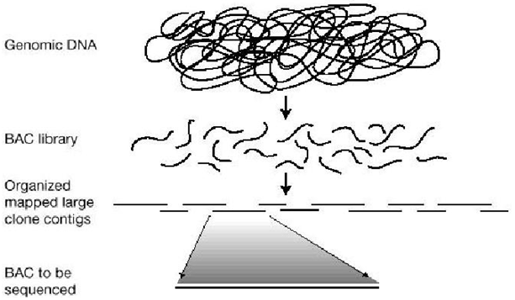

Genomes Characterization Techniques – PCR: Technique to amplify the DNA. Different variants of the technique used
Genomes Characterization Techniques – DNA Sequencing: One of the important techniques used to characterize the genomes. Used to study structure and function of genomes.
Genomes Characterization Techniques – Computational Tools: Used to align the sequenced DNA to produce physical maps of the genomes.
LESSON 136
Steps of Genomes Analysis: Followings are the steps which are used in genome analysis.
  - Genome sequence assembled
  - Identify repetitive sequences – mask out
  - Gene prediction – train a model for each genome
  - Look for EST and cDNA sequences
  - Genome annotation
  - Microarray analysis
  - Metabolic pathways and regulation
  - Protein 2D gel electrophoresis
  - Functional genomics
  - Gene location/gene map
  - Self-comparison of proteome
  - Comparative genomics
  - Identify clusters of functionally related genes
  - Evolutionary modeling

LESSON 137
Benefits of Genomes Research: Followings are the benefits of genome research
Genomes Research – Molecular Medicine
  - Improve diagnosis of disease
  - Detect genetic predispositions to disease (cancer, diabetes etc)
  - Create drugs based on molecular information
  - Use gene therapy and control systems as drugs
Genomes Research – Risk Assessment Evaluate the health risks faced by individuals who may be exposed to radiations and to cancer causing chemicals and toxins.
Genomes Research – Bioarcheology, Anthropology, Evolution and Human Migration: Study evolution through genetic variants in lineages.
Study of migration of different populations
Study mutations on the Y chromosome to trace lineage and migration of males and Evolution of mutations with ages of populations.
Genomes Research – DNA Forensics
  - Identify potential suspects whose DNA may match evidence left at crime scenes.
  - Exonerate persons wrongly accused of crimes.
  - Identify catastrophe victims.
  - Establish paternity and other family relationships.
  - Identify endangered and protected species as an aid to wildlife officials
  - Detect bacteria and other organisms that may pollute air, water, soil and food.
  - Match organ donors with recipients in transplant programs
  - Determine pedigree for seed or livestocks
Genomes Research – Disease-resistant crops and disease-resistant animals
  - Grow disease/insect resistant and drought-resistant crops.
  - Breed healthier, more productive, disease-resistant farm animals.
Genomes Research – Agriculture, Livestock Breeding, and Bioprocessing
  - Develop bio pesticides.
  - Incorporate edible vaccines incorporated into food products.
Genomes Research – Microbial Genomics
  - Rapidly detect and treat pathogens (disease-causing microbes).
  - Develop new energy sources (biofuels)
  - monitor environment to detect pollutants
  - Protect populations from biological and chemical warfare
  - Clean up toxic waste safely and efficiently

LESSON 138
Genes and Size of Genomes: Genomes of most bacteria and archaea range from 1 to 6 million base pairs (Mb). Genomes of eukaryotes are usually large. Most plants and animals have genomes greater than 100 Mb. Humans have genome size of 3,000 Mb Within each domain there is no systematic relationship between genome size and phenotype
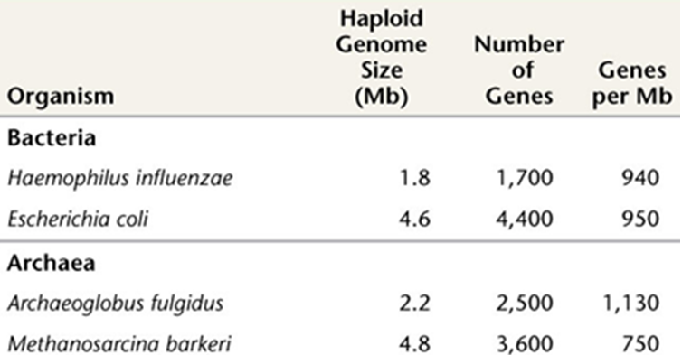

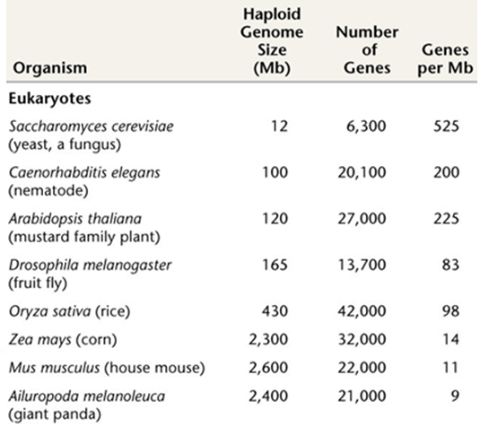

LESSON 139
Viral Genomes
Genomes of Viruses: A viral genome is the genetic material of the virus also termed as viral chromosome. Viral genomes vary in size -few thousand to more than a hundred thousand nucleotides. Viral genomes can be
ssRNA dsRNA
ssDNA dsDNA
Linear Ciruclar
Viruses with RNA Genomes: Almost all plants viruses and some bacterial and animal viruses Genomes are rather small (a few thousands nucleotides)
Viruses with DNA Genomes: Often a circular genome lambda = 48,502 bp
Replicative form of Viral Genomes: All ssRNA viruses produce dsRNA molecules. Many linear DNA molecules become circular
Viruses and Kingdoms: Many plants viruses contain ssRNA genomes. Many fungal viruses contain dsRNA genomes. Many bacterial viruses contain dsDNA genomes.
Genomes in Virions: The genomes of viruses can be composed of either DNA or RNA, and some use both as their genomic material at different stages in their life cycle. However, only one type of nucleic acid is found in the virion of any particular type of virus.

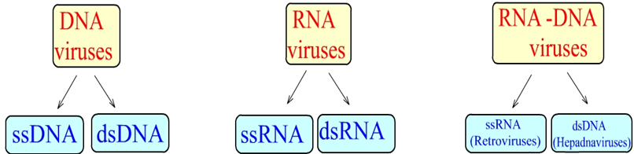

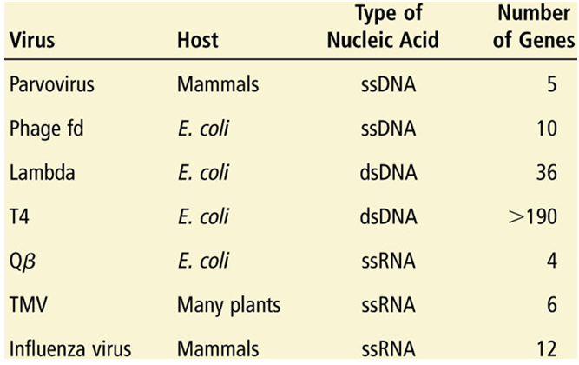

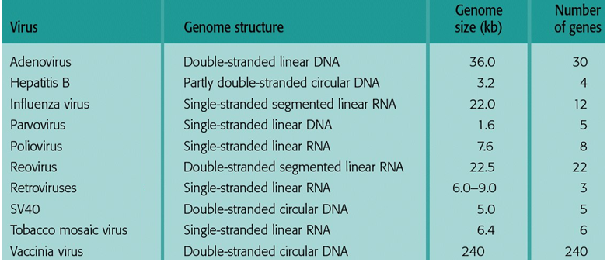
Viruses and Number of Genes

Genomes in Virions
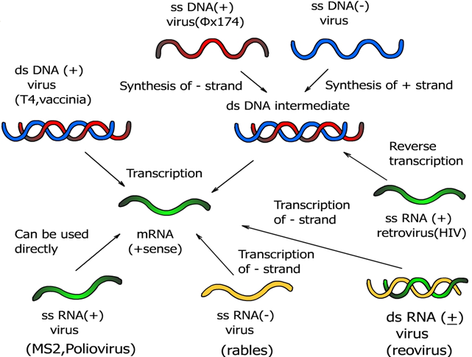

Genome of Tobacco Mosaic Virus
- Single, 6400 nucleotides RNA, 3 Essential Genes
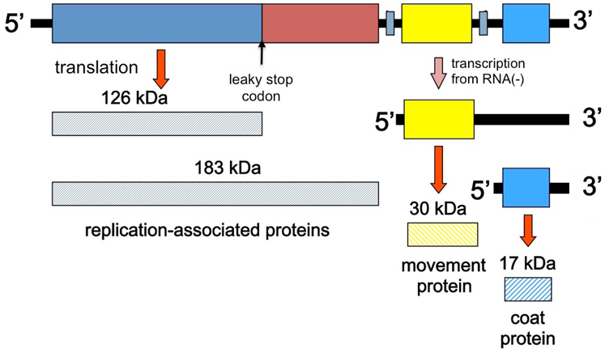

Genome of Poxvirus –A typical large dsDNA Virus
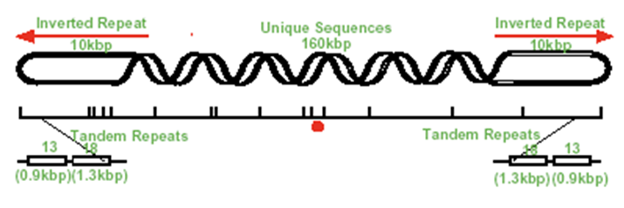
180 kb DNA, >100 Essential Genes

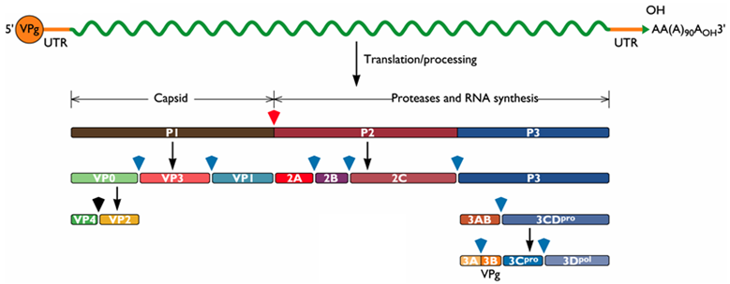
Genome of Polio Virus: Single-stranded positive-sense RNA genome that is about 7500 nucleotides long

Genome of Pox Virus
Linear dsDNA 130-375 kbp; covalently closed termini. Large hairpin structure at each terminus - up to 10 kb total at each end is repeat sequence. Encode 150-300 proteins. Coding regions are closely spaced, no introns. Coding regions are on both strands of genome, and are not tightly clustered with respect to time of expression or function.
LESSON 140
Bacterial Genomes: Small organisms carry high coding density (85-90%). 1 gene per 1000 bases in prokaryotes. Large variation in genome size between bacteria
Genomes of Bacteria – Large Variation
Tremblaya princeps 140kb, 121 coding sequences
Sorangium cellulosum
14000kb
11599 coding sequences
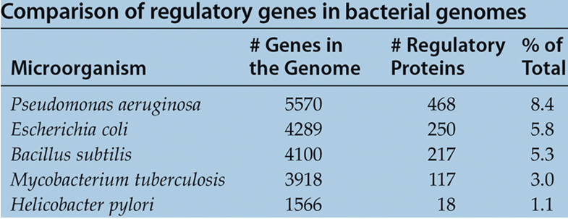

Distribution of genes among selected bacterial genomes and their sizes
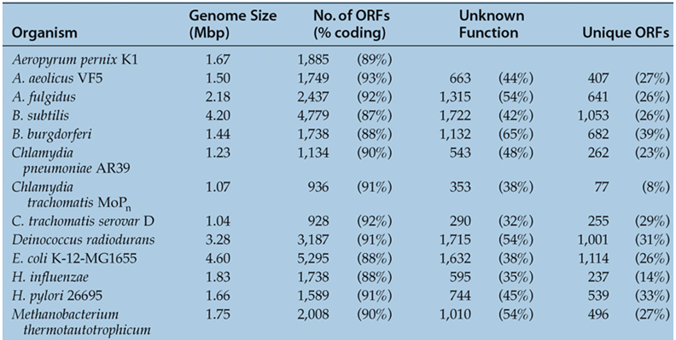

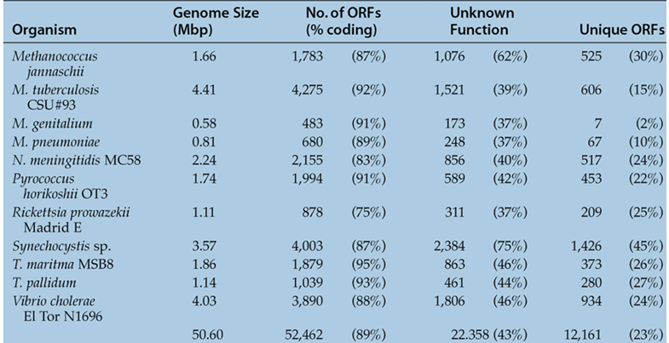
Genes in a portion of a bacterial genome
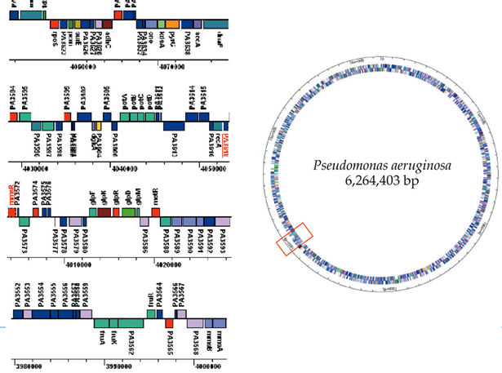
LESSON 141
Yeast Genome: The nuclear genome consists of 16 chromosomes. In addition, there is a mitochondrial genome and a plasmid, 2 micron circle. The haploid yeast genome consists of ~ 12.1 Mb. Yeast genome was completely sequenced by 1996.
Yeast Genome – Characteristics: Followings are the characteristics of yeast genome.
Small and compact with small intergenic séquences
Few transposable elements with few introns
Limited RNA interference
The yeast genome is predicted to contain about 6,200 genes and 274 tRNA and 287 introns
Small percentage of yeast genes have introns. The intergenic space between genes is only between 200bp - 1,000bp
The largest known regulatory sequences are spread over about 2,800bp , MUC1/FLO11
Yeast genes have names consisting of three letters and up to three numbers GPD1, HSP12, PDC6 . Usually they are meaningful

Yeast Genome: Genome of Yeast Cell
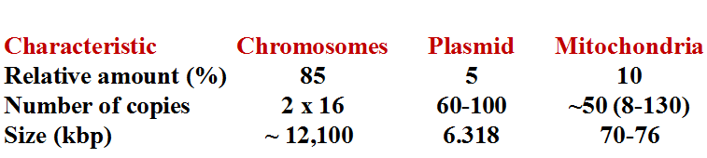

Yeast Genome – Genes Nomenclature
Wild type genes are written with capital letters in italics: TPS1, RHO1, CDC28. Recessive mutant genes are written with small letters in italics: tps1, rho1, cdc28. Three letters provides information about a function, mutant phenotype, or process related to that gene.
CDC - Cell Division Cycle; ADE-ADEnine biosynthesis

Yeast – Mitochondrial DNA
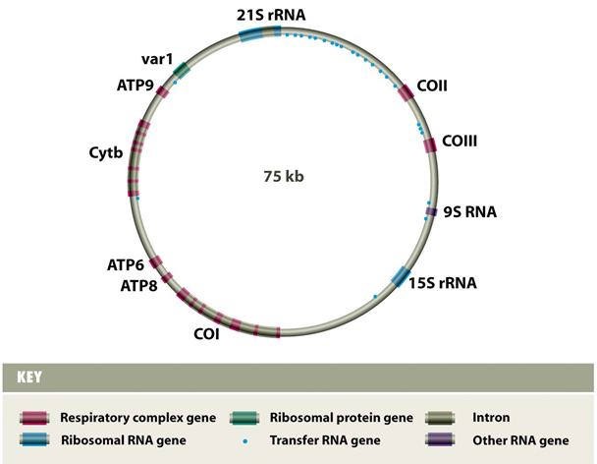

Yeast – Plasmid DNA
The 2u circle is a 6.3 kb. 50 to 100 copies per haploid genome of the yeast cells. ARS, the FLP gene, the three genes which encode proteins required for regulation of FLP expression (REP2, REP1, and D). Set of small direct repeats (called "STB") required for partitioning into daughter cells during mitosis and meiosis.
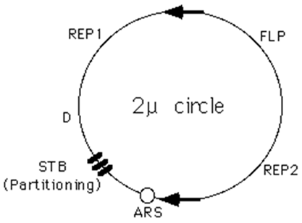

LESSON 142
Mitochondrial Genome: Multiple identical circular chromosomes
~15-16 Kb in animals
~ 200 kb to 2,500 kb in plants
Over 95% of mitochondrial proteins are encoded in the nuclear genome.
Often A+T rich genomes
Human Mitochondrial Genome: Circular, double stranded 16.6 kb. The two strands are notably different in base composition, leading to one strand being heavy (H strand) and the other light (L strand). Both strands encode genes, although more are on the H strand. A short region (1121 bp), the D loop is a DNA triple helix: two overlapping copies of the H strand. The D loop is also the site where most of replication and transcription is controlled. Genes are tightly packed, with almost no non-coding DNA outside of D loop. Human mitochondrial genes contain no introns, although introns are found in the mitochondria of other groups (plants)
- 37 Genes
- 22 tRNAs
- 2 rRNAs
- 13 polypeptides
- tRNA: only 60 of the 64 codons code for amino acids.
Mitochondrial Genome - Humans
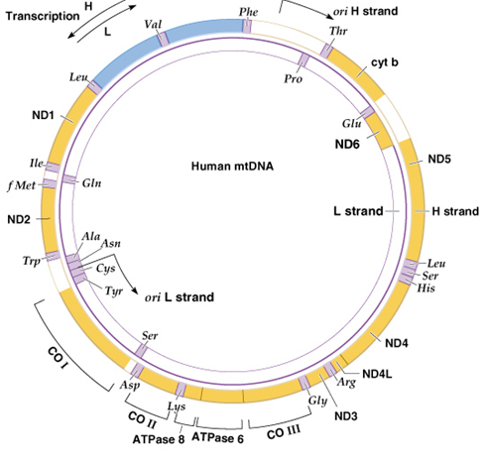

Mitochondrial Genome – Yeast
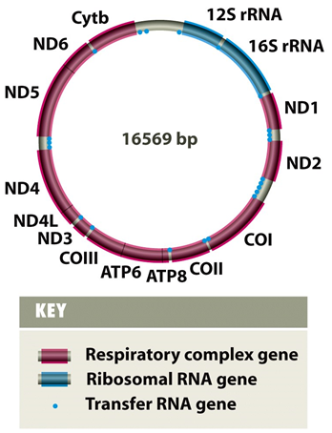

Mitochondrial Genome – Human and Yeast
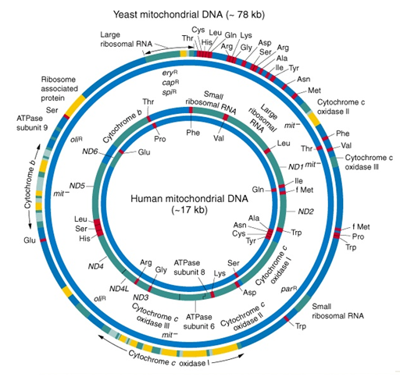

Mitochondrial Genomes
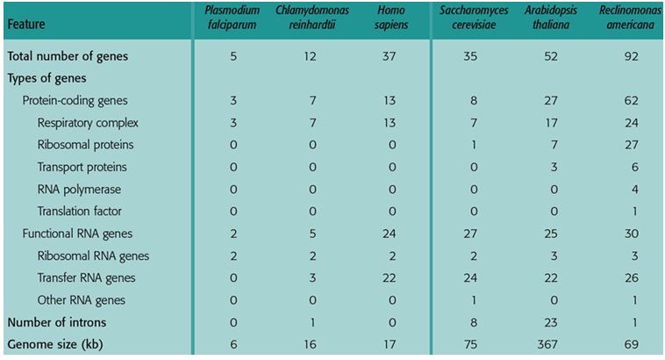

Universal Code and Mitochondrial Code
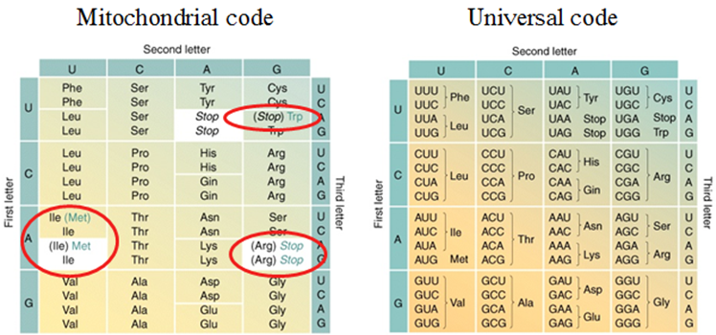

Mitochondrial Genome – Tumors due to mutations
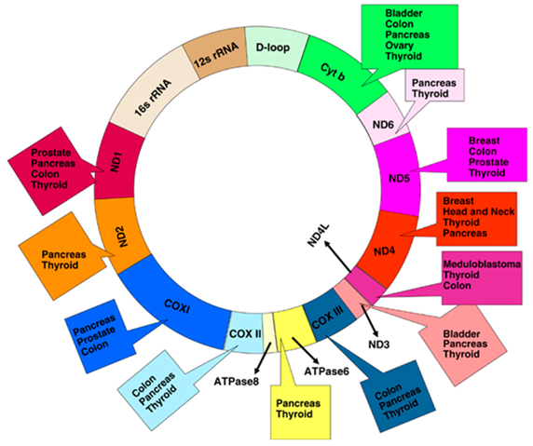

Mitochondrial DNA polymorphisms track human migrations
All humans descend from a small group of Africans. This group originated in central Africa ~200,000 years ago. The founding group was small (102-104 people)
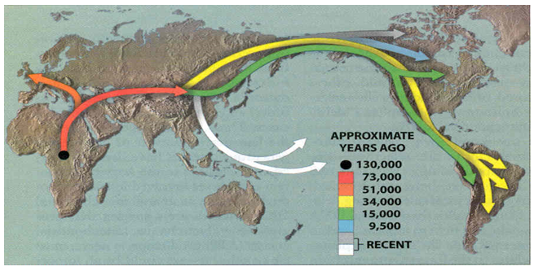

LESSON 143
Chloroplast Genome (cpDNA): Multiple circular molecules. Size ranges from 70 kb to 2000 kb. Land plants typically 120 – 170 kb. Similar to mtDNA
- ~ 70 kb – Epifagus
- ~2,000 kb – Acetabularia
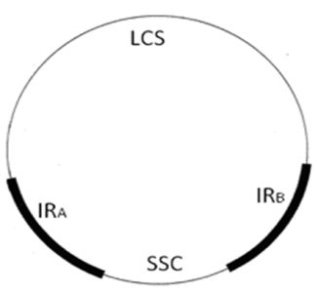
Many chloroplast proteins are encoded in the nucleus (separate signal sequence). Double stranded DNA molecule. Chloroplasts genomes are relatively larger. Multiple copies of genome are present. Large enough to code 50-100 proteins as well as rRNAs & tRNAs. cpDNA regions includes Large Single Copy (LSC), Small Single Copy (SSC) regions, and Inverted Repeats (IRA & IRB).

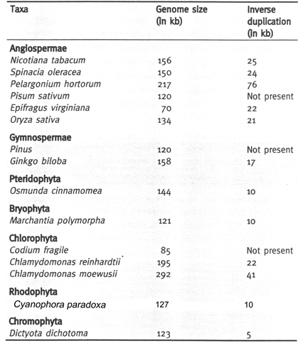
Chloroplast Genomes: Size in different Taxa

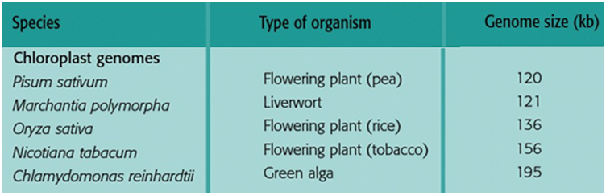
Chloroplast Genome Size

Chloroplast Genome of Rice

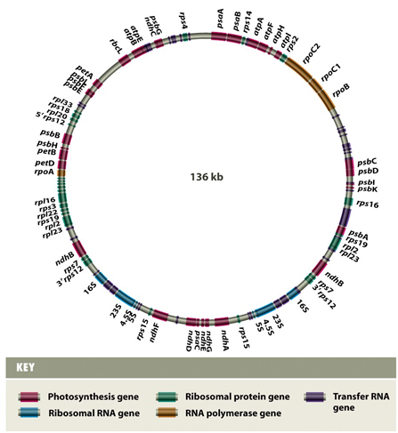

Functions of Chloroplast Genes: Most cp genes fall into two functional groups:
Genes involved in replication, transcription, translation
Genes involved in photosynthesis
Genes Nomenclature Based on bacterial naming system, which uses lower case letters, and a descriptive prefix, based on the probable function. If the gene product is part of a multi-subunit complex, a letter of the alphabet is used to denote different subunits.
- psa for genes of photosystem I (psaA, psaB, etc.)
- psb for genes of photosystem II (psbA, psbB, etc.)
Properties of Chloroplast Genome
- Non-mendelian inheritance
- Self-replication
- Somatic segregation in plants
- Inherited independently of nuclear genes
- Conservative rate of nucleotide substitution enables to resolve plant phylogenetic relationships at deep levels of evolution.

LESSON 144
Eukaryotic Genomes: Located on several chromosomes; relatively low gene density. Carry organelles genome in addition to nuclear genome. Eukaryotic genomes contains repetitive sequences like
- SINEs (short interspersed elements)
- LINEs (long interspersed elements)
LINES SINES
- 1-5 kb 200-300 bp
- 10-10,000 copies 100,000 copies
Highly repetitive: Minisatellites, Microsatellites, Telomeres
Minisatellites: Repeats of 14-500 bp. 1-5 kb long. Scattered throughout the genome
Microsatellites: Repeats up to 13 bp
Telemeres: Short repeats (6 bp). 250-1,000 at ends of chromosomes

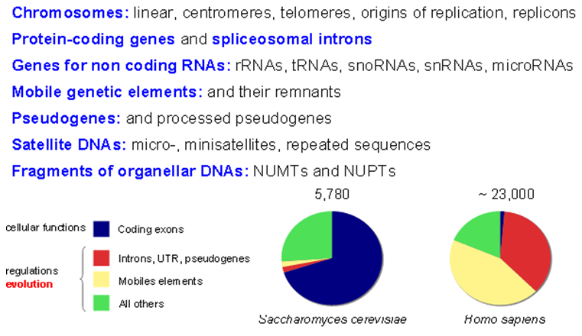
Elements of Eukaryotic Genomes

Comparison - Prokaryotic & Eukaryotic Genomes
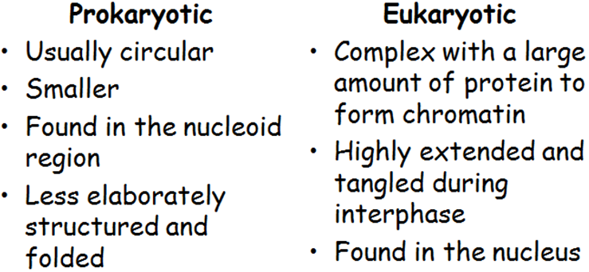

LESSON 145
Genomes Comparisons
Genomes vary in size Genomes of most bacteria and archaea range from 1 to 6 million base pairs (Mb). Most plants and animals have genomes greater than 100 Mb; humans have 3,000 Mb
Genomes vary in genes numbers: Free-living bacteria and archaea have 1,500 to 7,500 genes. Fungi have about 5,000 genes and multicellular eukaryotes upto 40,000 genes. Number of genes is not correlated to genome size
Nematode C. elegans has 100 Mb and 20,000 genes, while Drosophila has 165 Mb and 13,700 genes. Vertebrate genomes can produce more than one polypeptide per gene because of alternative splicing of RNA transcripts
Humans and Mammals have low gene density: Humans and other mammals have the lowest gene density, or number of genes, in a given length of DNA. Multicellular eukaryotes have many introns within genes and noncoding DNA between genes
Multicellular eukaryotes have much noncoding DNA and multigene families
Most of eukaryotic genomes neither encode proteins nor functional RNAs. Evidence indicates that noncoding DNA plays important roles in the cell
Human Genome: Distribution of coding and non-coding DNA
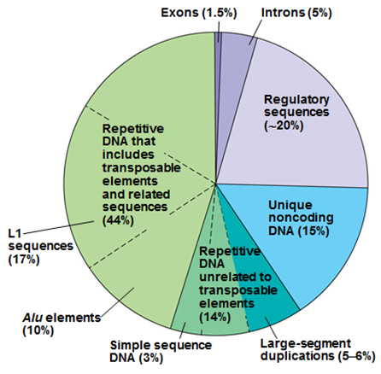

Comparing Genomes
Significant similarity between genomes of “distant” species like (Man – Yeast: 23%)
Similarity increases for taxonomically close species.
Closely related species help us understand recent evolutionary events
Distantly related species help us understand ancient evolutionary events
Comparing Genomes: Bacteria, archaea, and eukaryotes diverged from each other between 2 and 4 billion years ago
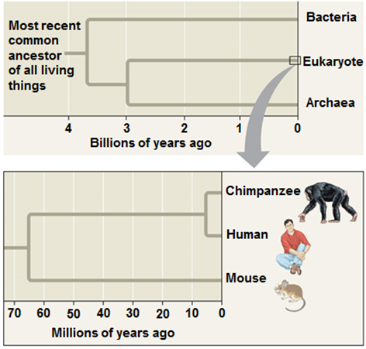

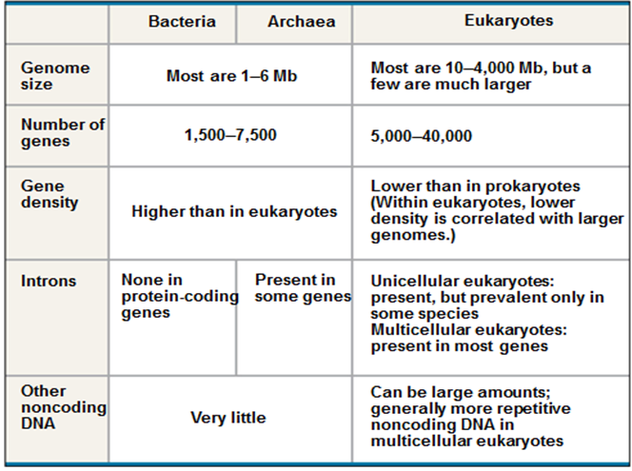

Comparing Genomes: Human and chimpanzee genomes differ by 1.2%, at single base-pairs, and by 2.7% because of insertions and deletions
LESSON 146
Comparing Distantly/Closely Related Species
Comparing distantly related species: Highly conserved genes have changed very little over time. These help to clarify relationships among species that diverged from each other long ago. Bacteria, archaea, and eukaryotes diverged from each other 2 and 4 billion years ago. Highly conserved genes can be studied in one model organism.
Comparing closely related species: Genetic differences between closely related species can be correlated with phenotypic differences. Genetic comparison of several mammals with non-mammals helps to identify what make mammals. Human and chimpanzee genomes differ by 1.2%, at single base-pairs, and by 2.7% because of insertions and deletions. Several genes are evolving faster in humans than chimpanzees. Genes involved in defense against malaria and tuberculosis and in regulation of brain size, genes code for transcription factors. Humans and chimpanzees differ in the expression of the FOXP2 gene, whose product turns on genes involved in vocalization. Differences in the FOXP2 gene may explain why humans but not chimpanzees communicate by speech.
Conclusion: Highly conserved genes have changed very little over the time. These help to clarify relationships among species that diverged from each other long ago

LESSON 147
Anatomy and Organization of Genomes
Genome Anatomy: Anatomy of different genomes differs from each other. Eukaryotes and prokaryotes genomes differ very significantly
Size of genomes; there can be 1000 fold difference between eukaryotes and prokaryotes genomes
~ 30 fold between genomes of different eukaryotes
In humans ~ 23,000 while bacterial genomes ~ 1,500 – 2,000 genes
Genome Anatomy – Eukaryotes: Eukaryotic genomes are full of simple repeats, numerous types of transposable elements and other sequences.
Genome Anatomy – Prokaryotes: Prokaryotes have a few repeats and transposable elements and their genomes consist of mainly the genes.
Genome Organization
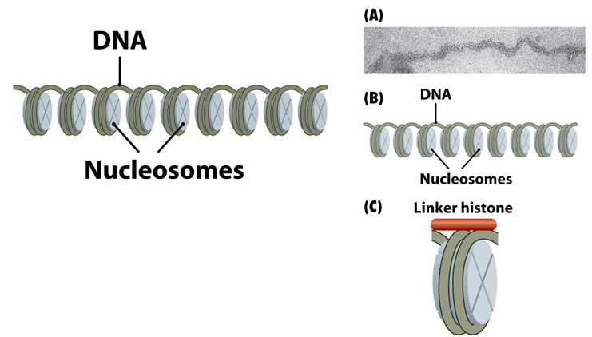

Genome Organization in Prokaryotes
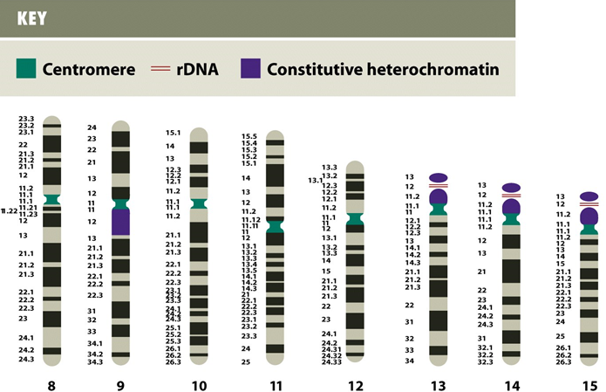
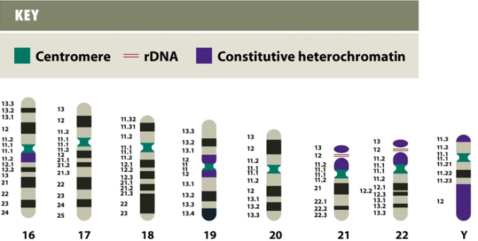
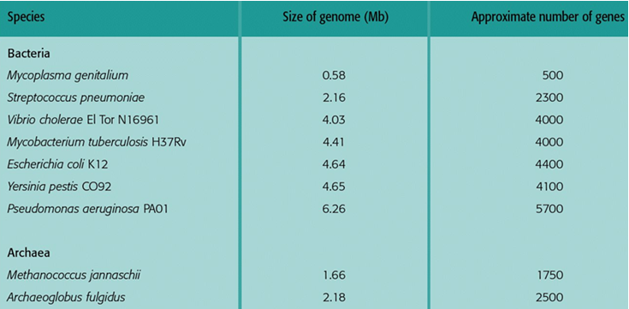
Genome Organization in Prokaryote

Genome Organization: Comparisons
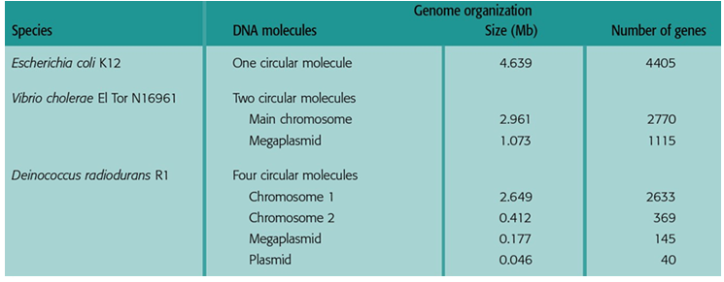

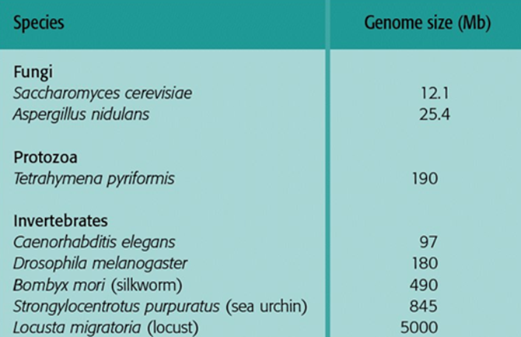

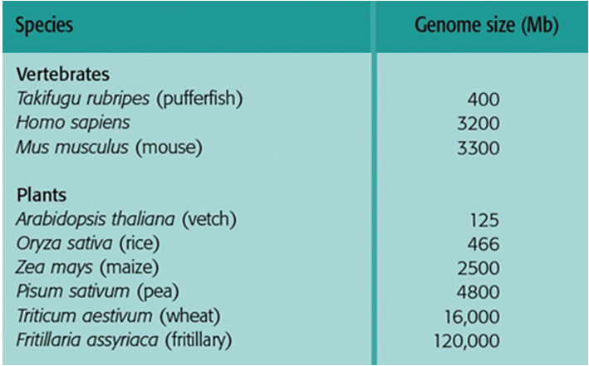

Genome Organization: Human, Yeast, Fruit Fly , Maize
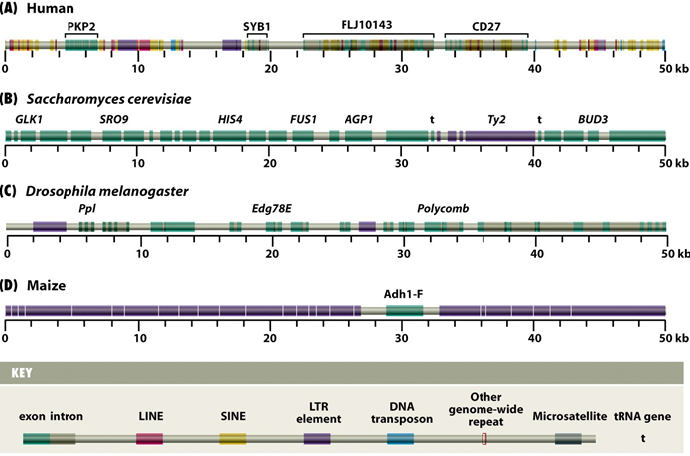
Compactness of Genomes
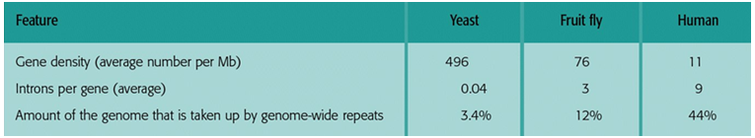
LESSON 148
Gene Anatomy
What is Gene? : A piece of DNA (or RNA) that contains the primary sequence to produce a functional biological gene product (RNA or protein). Entire nucleic acid sequence necessary for the synthesis of a functional polypeptide (protein chain) or functional RNA.
Genetic information is stored in DNA. Segments of DNA that encode proteins or other functional products are called genes. Gene sequences are transcribed into messenger RNA (mRNA).
mRNA is translated into Proteins. mRNA intermediates are translated into proteins that perform most of the life functions.
Gene Anatomy: Three components
- Open Reading Frame: From start codon (ATG) to stop (TGA, TAA, TAG)
- Upstream region with binding site. (e.g. TATA box, GC box, CAAT box)
- Poly-a tail
Gene Anatomy – Typical Prokaryotic Gene
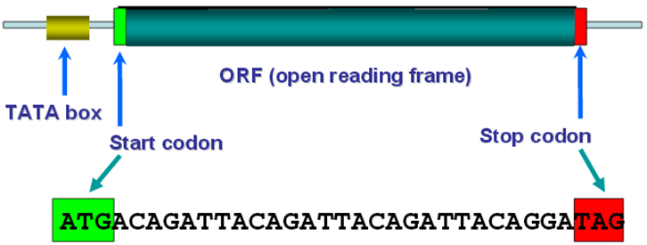

Gene Anatomy – Typical Eukaryotic Gene
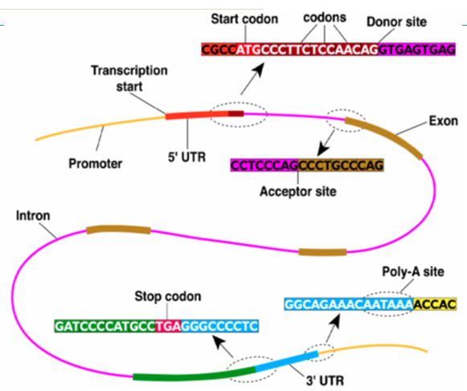

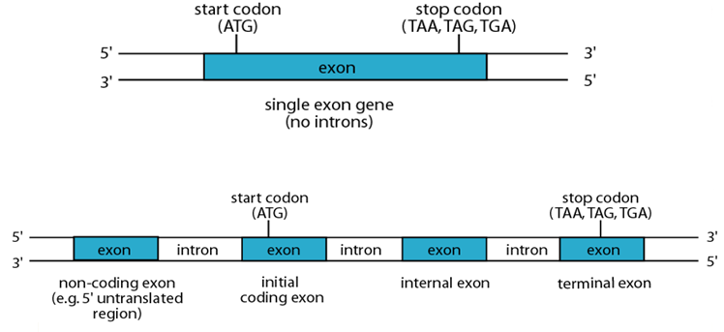
Single Exon Gene and Multiple Exons Gene
LESSON 149
Prokaryotic Gene and Eukaryotic Gene
Bacterial Gene: Most of the bacterial genes do not have introns. Many are organized in operons: contiguous genes, transcribed as a single polycistronic mRNA, which encode proteins with related functions. Polycistronic mRNA encodes several proteins

Bacterial Gene: Polycistronic mRNA encodes several proteins
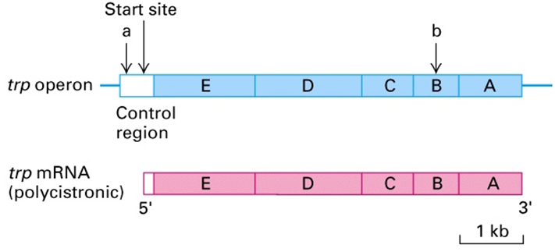
Eukaryotic Gene: Exons and Introns
Introns: intervening sequences within a gene that are not translated into a protein sequence.
Exons: sequences within a gene that encode protein sequence.
Splicing: Removal of introns from the mRNA molecule

Eukaryotic Gene : Splicing: Removal of introns from the mRNA molecule
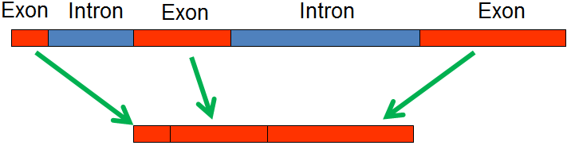
Eukaryotic Gene: Organize expression of genes’ (function calls). Promoter region (binding site), usually near coding region. Binding can block (inhibit) expression
Alternative Splicing in Eukaryotic Genes: Most have introns. They produce monocistronic mRNA. They are large in size.

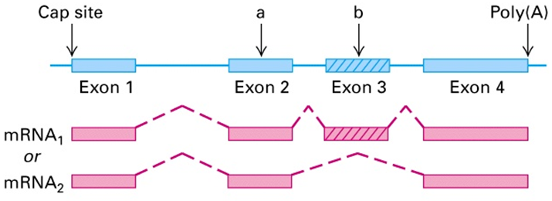
Eukaryotic Gene: Alternative Splicing

LESSON 150
Types of Eukaryotic DNA
- Protein coding genes
- Tandemly repeated genes
- Repeated DNA
- Unclassified spacer DNA

Protein coding genes can also be in the form of:
- Duplicated and diverged genes
- Functional gene families and non-functional pseudo-genes
- Tandemly repeated genes encoding rRNA, 5sRNA, tRNA and histones.

Repetitive DNA
- Simple sequence DNA
- Moderately repeated DNA (mobile DNA elements)
- Tranposones
- Retrotransposons
- Long interspersed elements
- Short interspersed elements
- Unclassified spacer DNA

Major Classes of Eukaryotic DNA in Human Genome
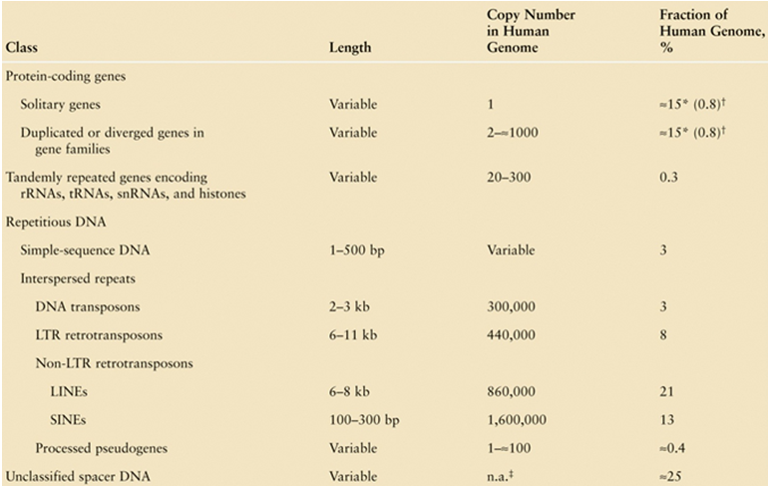

LESSON 151
Duplicated Genes and Pseudo-Genes
Duplicated Genes: Encode closely related (homologous) proteins. They are usually clustered together in genome. They are usually formed by duplication of an ancestral gene followed by mutation
Pseudo-Genes: They are nonfunctional copies of genes. They are formed by duplication of ancestral gene, or reverse transcription and integration.
Duplicated Genes: Five functional genes and two pseudo-genes
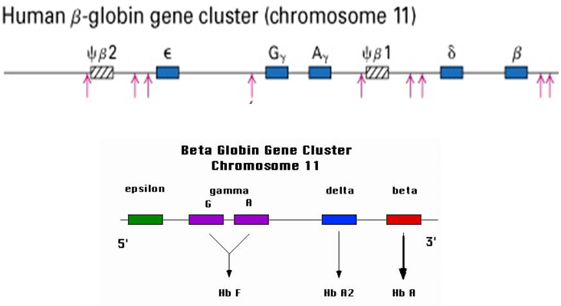

Pseudo-Genes: Not expressed due to mutations that produce a stop codon or prevent mRNA processing or due to lack of regulatory sequences

Pseudo-Genes: In below example there are five functional genes and two pseudo-genes
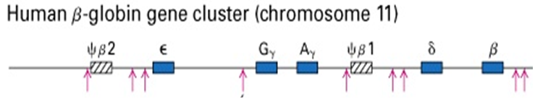

Gene’s duplication: Globin family Ancestral globin gene was duplicated ~ 500 million years ago. Mutations in both genes to differentiate them - α and β present in all higher vertebrates. Further gene duplications produced alternative forms in mammals and in primates
Genes Duplication: Globin Family
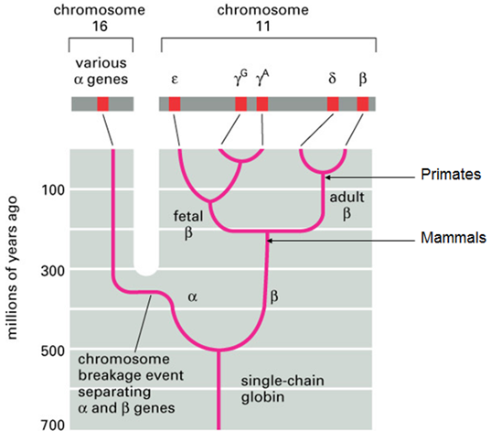

DNA Duplications: Two phenomenons are common in DNA duplications.
- Slipped strand mispairing
- Unequal crossover during recombination

DNA Duplications: Slipped strand mispairing
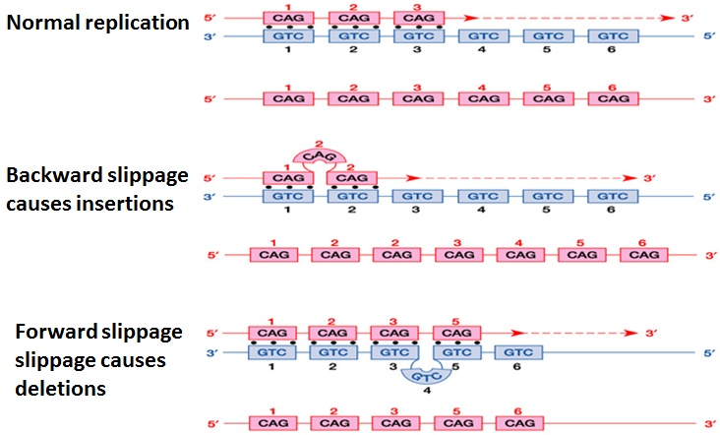

DNA Duplications: Unequal Cross Over
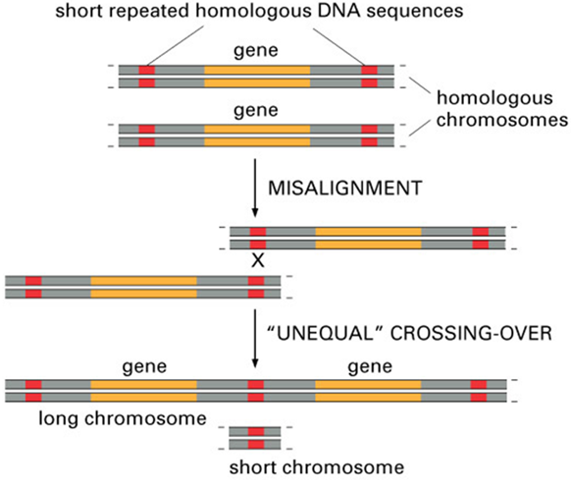

Pseudo-Genes
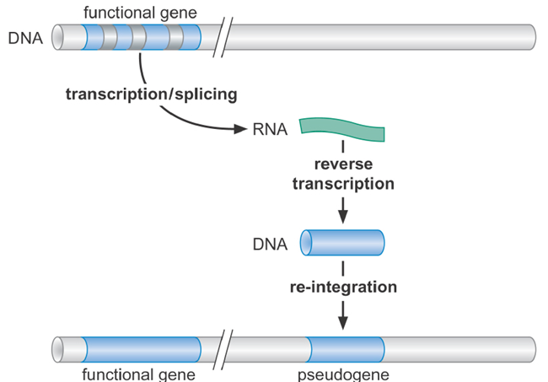

Functional Genes: Process of evolution produced truncated genes and gene fragments
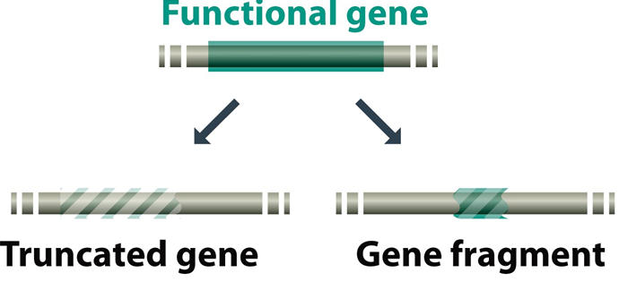

LESSON 152
Repetitive DNA
Chromosomes - highly dynamic: There can be whole genome duplication. The genomes of two distinct species can merge. An individual can acquire an extra copy of a chromosome. Chromosomes can fuse; e.g. human chromosome 2 derived from a fusion of two ancestral primate chromosomes. Chromosomal regions can be inverted or deleted. Segmental and other duplications can occur
Five main classes of Repetitive DNA
Interspersed Repeats: Retrotransposons constitute over 40-45% of the human genome and consist of several millions of family members. They play important roles in shaping the structure/evolution of the genome.
Processed Pseudogenes: These genes have a stop codon, frameshift mutation, or loss of promoter activity and do not encode a functional protein. They commonly arise from retrotransposition, or following gene duplication and subsequent gene loss.
Simple Sequence Repeats
- Microsatellites (1-12 bp)
- Minisatellites (12-500 bp)
Segmental Duplications: Segmental duplications blocks of about 1 kb to 300 kb that are copied within or between chromosomes. They are ∼5% of human genome.
Blocks of Tandem Repeats: Blocks of tandem repeats includes telomeric and centromeric repeats and can span millions bp. Often species specific.
Repeats in Mouse genome
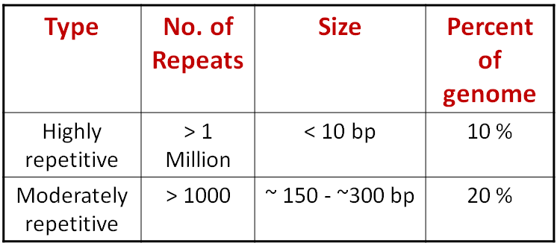

LESSON 153
Mobile DNA: DNA that Move within genomes. Most of moderately repeated DNA sequences found throughout higher eukaryotic genomes. Most mobile DNAs are transposable elements that include DNA-based transposons and retro-transposons. Some encode enzymes that catalyze movement.
Mobile DNA – Types of Transposons
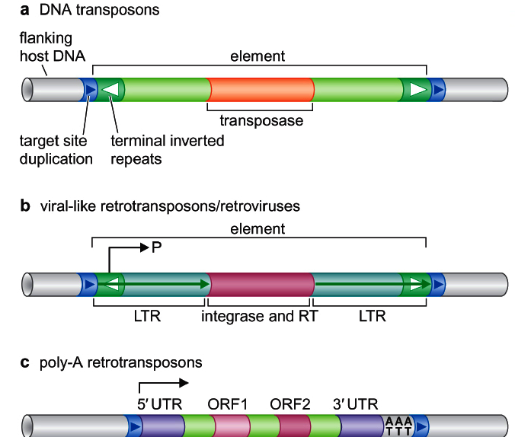

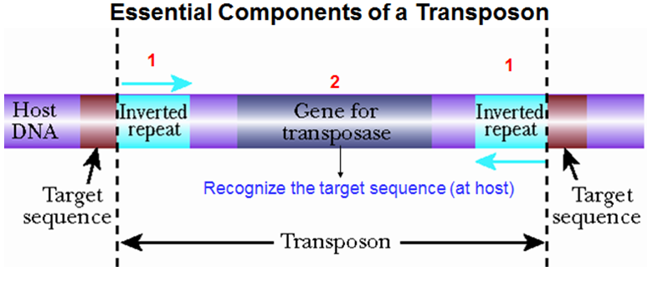
Mobile DNA Transposon is cut off by transposase and inserted on another site

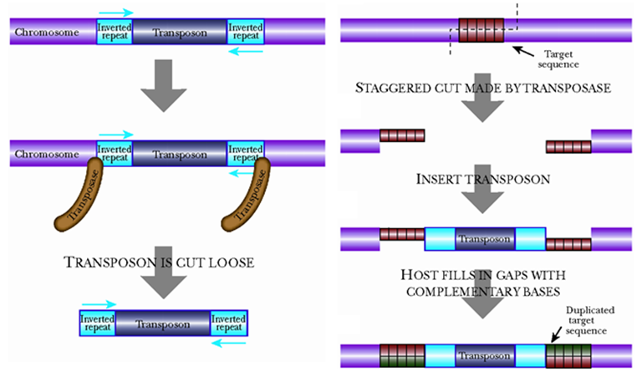

Components of a Complex Transposon

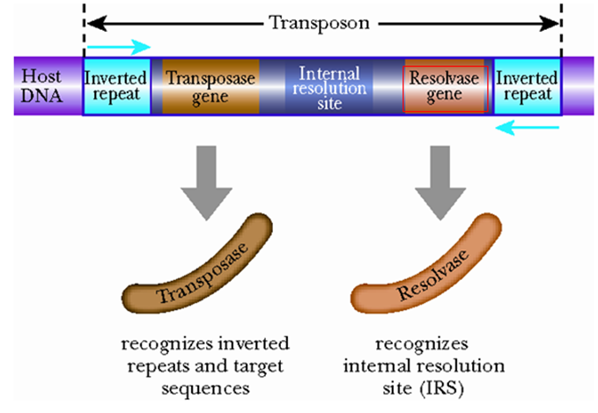

Ac and Ds Elements of Maize – Higher Life Form
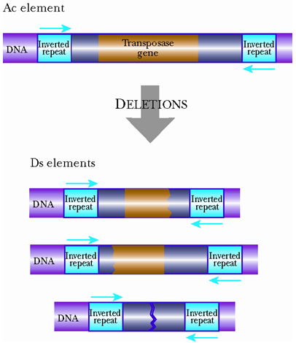

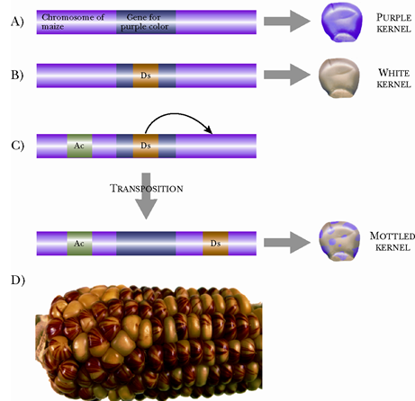
Movement of Ds Elements Gives Mottled Corn

Mobile DNA – Transposition: Transposition is movement of mobile DNA. It involves copying of mobile DNA element and insertion into new site in genome. Molecular parasite: “selfish DNA”
Mobile DNA - Retro transposition: Moving in the form of RNA by element coding for reverse transcriptase
- LINEs
- SINEs
- retrovirus-like elements (long terminal repeat)

Mobile DNA – Interspersed Repeats in Human Genome
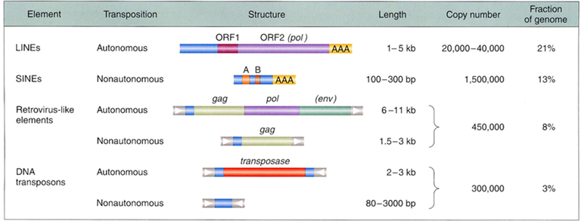

Mobile DNA – Fuel for Evolution: Probably have significant effect on evolution by facilitating gene duplication, which provides the fuel for evolution, and exon shuffling

LESSON 154
Movement of Transposons and Retro-transposons
Movement of Transposons: Eukaryotic transposable elements - two types
Transposons, which move by means of a DNA intermediate
Retrotransposons, which move by means of an RNA intermediate
Transposons
- Transposons - major content of eukaryotic genomes
- ~50% of Human/Mouse
- ~75% of the maize genome
- ~85% of the barley genome
- ~98% of the iris genome

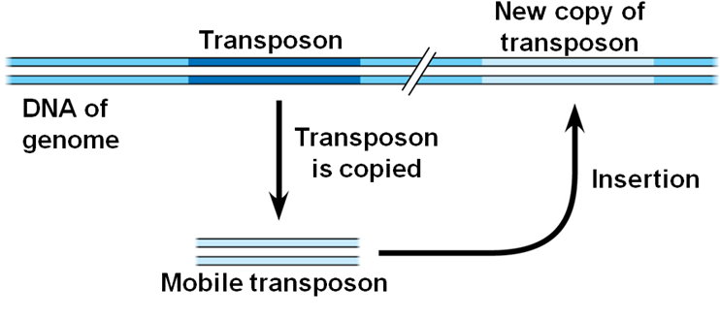
Movement of Transposons

Movement of Retrotransposons
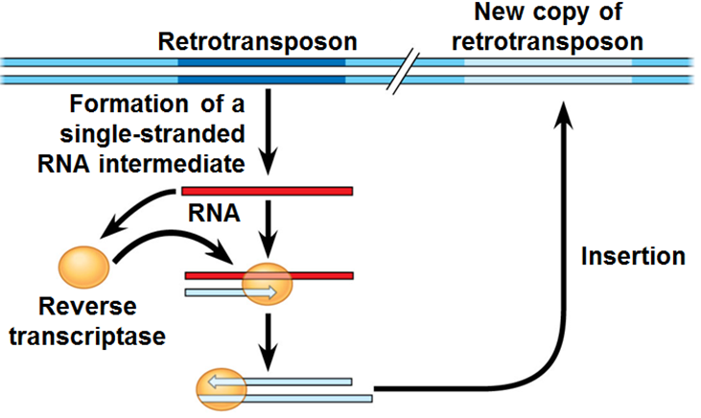

Transposons moves using DNA intermediate
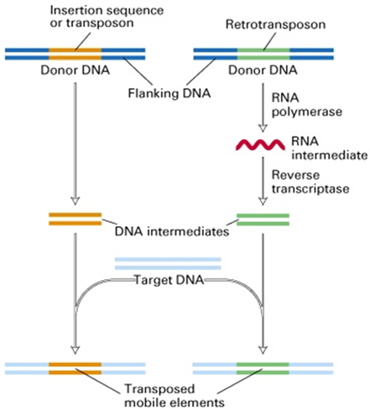

Retrotransposon moves using RNA intermediate
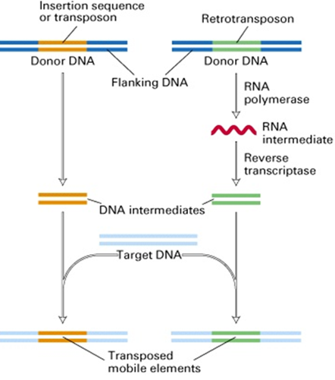

Eukaryotic transposable elements - two types
- Transposons, which move by means of a DNA intermediate
- Retrotransposons, which move by means of an RNA intermediate

LESSON 155
Transposons in Prokaryotes and Eukaryotes: Two types of transposons in prokaryotes i.e.
- Insertion Sequence (IS)
- Transposons (Tn) and Bateriophage Mu
Transposons in Prokaryotes: IS Elements: Prokaryotic IS elements range in size from 768 bp to over 5 kb. IS1 is 768 bp long, and present in 4–19 copies on the E. coli chromosome. IS2 has 0–12 copies on the chromosome, and 1 copy on the F plasmid. IS10 is found in R plasmids
The ends of all sequences (IS elements) show inverted terminal repeats (IRs) of 9–41 bp (e.g., IS1 has 23 bp of nearly identical sequence).
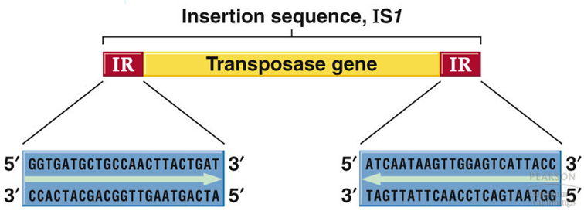

Transposons in Prokaryotes: IS Elements
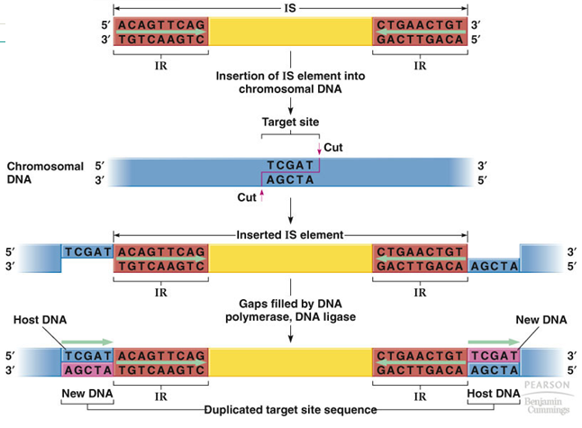

Transposons are similar to IS elements, but carry additional genes, and have a more complex structure. Two types of prokaryotic transposons:
- Composite transposons carry genes (e.g., antibiotic resistance) flanked on both sides by IS elements (IS modules). Example Tn10
- Non-composite transposons also carry genes (e.g., drug resistance) but do not terminate with IS elements.
Transposons in Prokaryotes: Composite Tn10
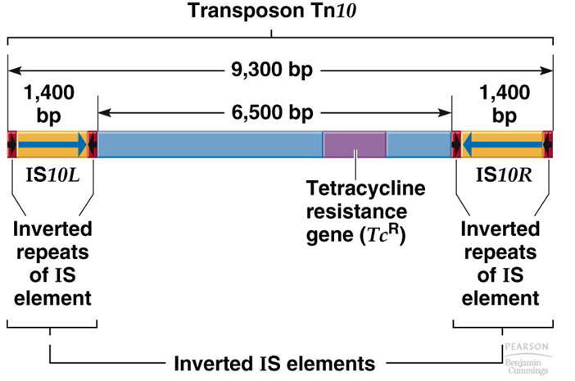

Transposons in Prokaryotes: Non-composite Tn3
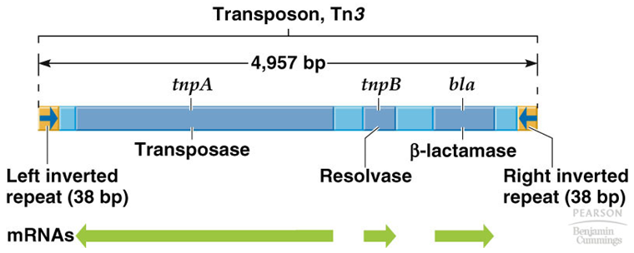

Transposons in Prokaryotes: Non-composite Tn3
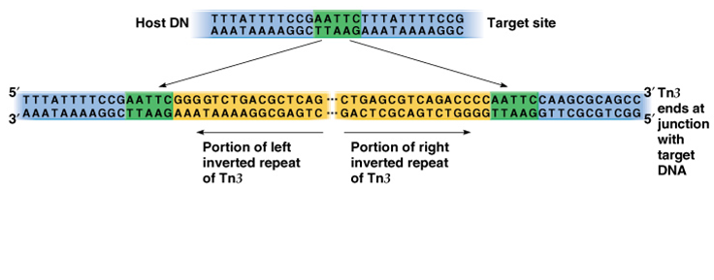
Transposons in Eukaryotes: Ty Elements in Yeast
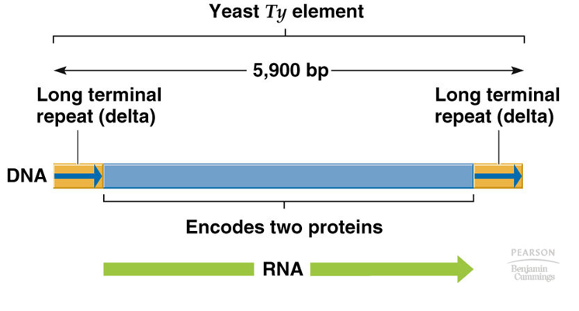

Transposons in Eukaryotes: Ac and Ds Elements
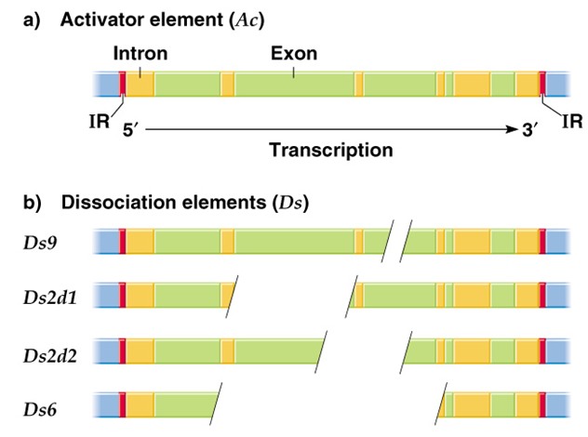

Transposons in Eukaryotes: Ac and Ds Elements in Maize
- Ac is 4,563 bp, with 1 1-bp imperfect terminal IRs and 1 transcription unit producing a 3.5 kb mRNA encoding an 807 amino acid transposase.
- Ac activates Ds to transpose or break the chromosome where it is inserted.
- Ds elements vary in length and sequence, but all have the same terminal IRs as Ac, and many are deleted or rearranged versions of Ac

LESSON 156
Long Terminal Repeats: Eukaryotic retrotransposons fall into two major groups:
- LTR retrotransposons
- Non-LTR retrotransposons
LTRs stand for Long direct Terminal Repeats. LTRs consist of 250-600 bp direct repeat sequences located at the ends of the retrotransposon coding region. Flank viral retrotransposons and retroviruses. Contain regulatory sequences like transcription start site and poly (A) site
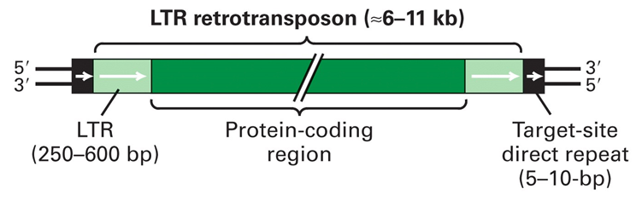

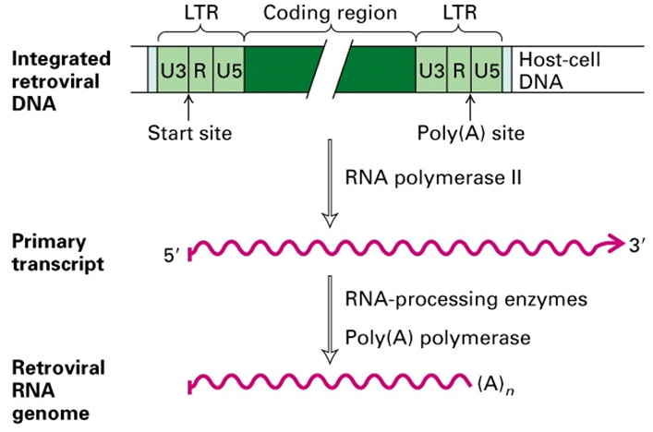

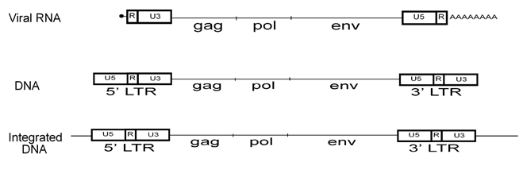

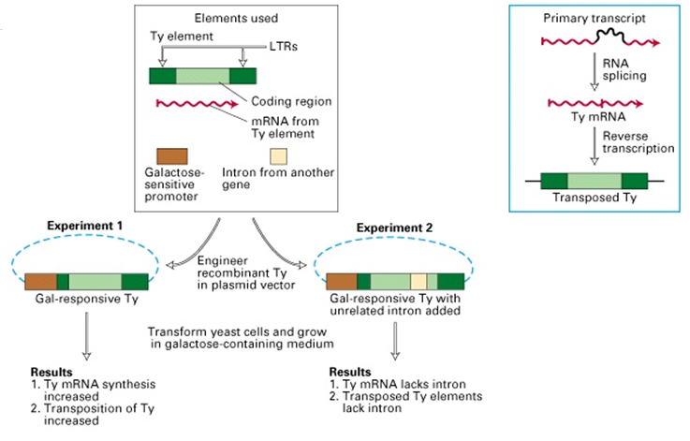

LESSON 157
Long Interspersed Nuclear Elements and Short Interspersed Nuclear Elements
Non-LTR retrotransposons consist of two sub-types;
- Long Interspersed Nuclear Elements (LINEs)
- Short Interspersed Nuclear Elements (SINEs)
High copy numbers in the plants species. They are widespread in eukaryotic genomes. LINEs possess two ORFs, which encode all the functions needed for retrotransposition
LINEs: Functions of ORFs include; reverse transcriptase, endonuclease activities, in addition to a nucleic acid-binding property needed to form a ribonucleoprotein
SINEs: SINEs, on the other hand, use the LINE machinery and function as non-autonomous retro-elements
LINEs: Several subgroups, such as L1, L2 and L3. Human coding L1 begin with an untranslated region (UTR) that includes an RNA polymerase II promoter, two non-overlapping open reading frames (ORF1 and ORF2), and ends with another UTR. ORF1 encodes an RNA binding protein and ORF2 encodes a protein having an endonuclease
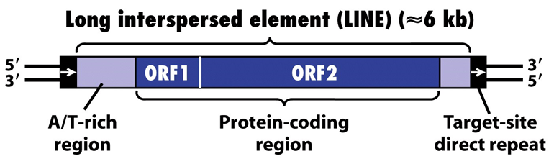

The 5' UTR contains the promoter sequence, while the 3' UTR contains a polyadenylation signal (AATAAA) and a poly-A tail. Human genome contains about 500,000 LINEs
Short Interspersed Elements: ~300 base pairs. Alu . ~ 11-13% of human genome

LINEs and SINEs: The sequences of LINE and SINE look like simple genes.
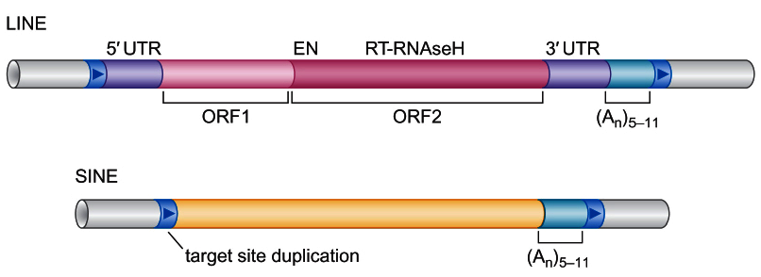

Short Interspersed Elements: Short DNA sequences ~ 300 bases that represent reverse-transcribed RNA molecules. SINEs do not encode a functional reverse transcriptase protein and rely on other mobile elements for transposition. In some cases they may have their own endonuclease that will allow them to cleave their way into the genome. The most common SINEs in primates are called Alu sequences. Alu elements are approximately 350 base pairs long, do not contain any coding sequences, and can be recognized by the restriction enzyme AluI. SINEs make up ~ 11-13% of human genome

LESSON 158
Genetic Variations: Variation between individuals of a population (within species) can be due to differences in the nucleotide sequence. How genetic variations emerge?
- Genetic Variations can be due to the mutations
- Genetic Variations can be due to the Recombination
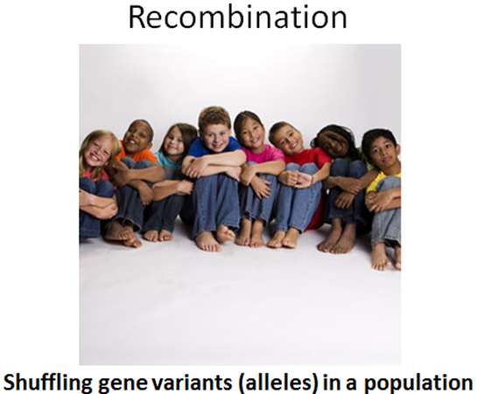
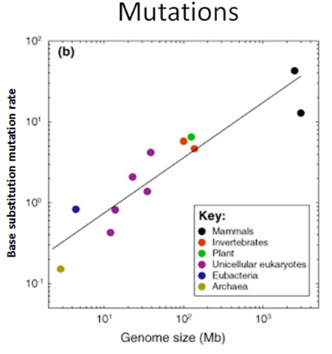

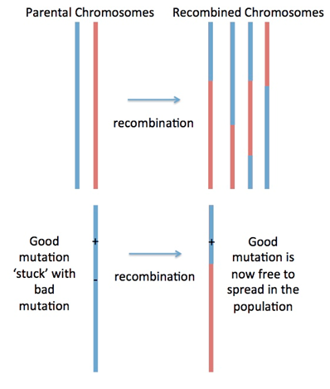

Genetic Variations: Genes Flow
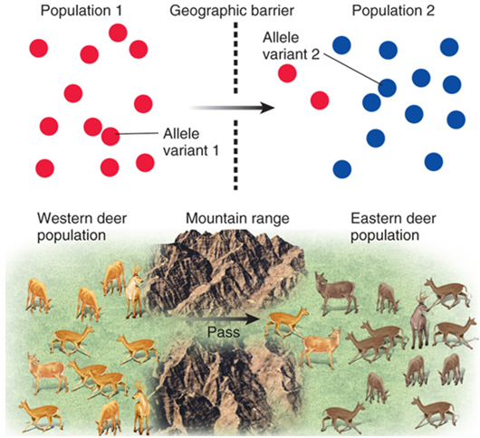

Genetic Variations: Genetic Drift: Change in the frequency of a gene variant (allele) in a population due to random sampling of organisms
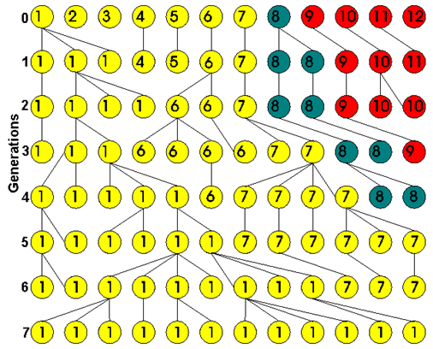

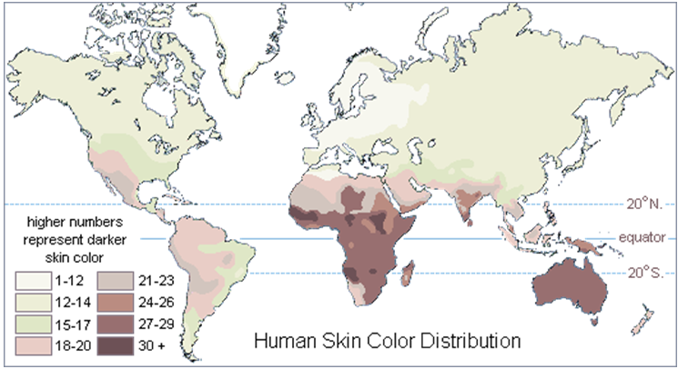
Genetic Variations: Humans Skin Color

Genetic Variations: Yellow Brown Hair Australian natives
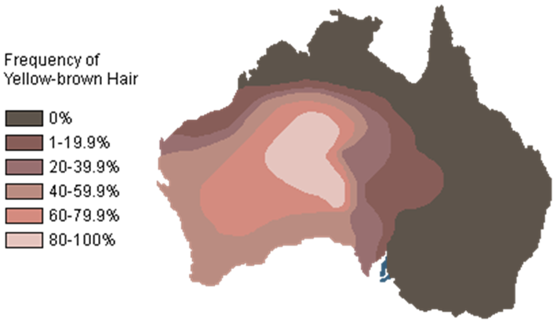

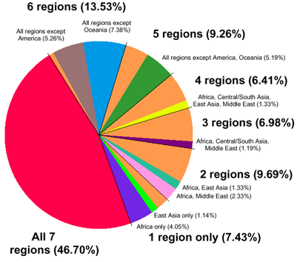
Genetic Variations: Microsatellites

Genetic Variations – Humans: Two genomes are roughly 99.9% identical to each other. If human genome is 3.0 billion bp then, there are 3.0 million differences between any two genomes.

LESSON 159
Genes Families and Genes Clusters
Genes Clusters: Many genes are arranged in groups along a chromosome - Genes Clusters. Eukaryotic ribosomal RNA genes: tandem repeats
Genes Families: Related genes may be organized as several clusters at different locations. These are known as gene families’ e.g. Globin genes family
Single Copy Genes and Genes Families: Many eukaryotic genes are present in one copy per haploid set of chromosomes. The rest of the genes occur in multigene families, collections of identical or very similar genes
Gene Family and Family members -
- Peroxiredoxin family
- PRDX is the root symbol
- Family members are PRDX1, PRDX2, PRDX3, PRDX4, PRDX5 and PRDX6
Genes Families: Some multigene families consist of identical DNA sequences, usually clustered tandemly, such as those genes that code for rRNA products

Ribosomal RNA Gene Family

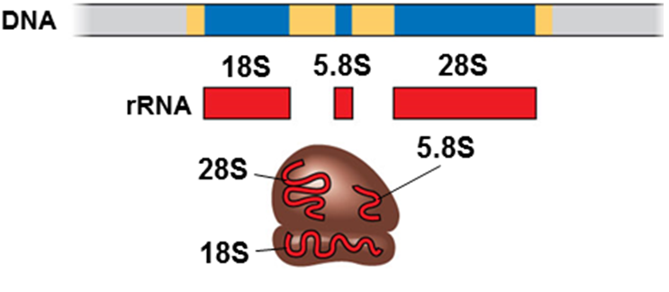

Human Alpha & Beta Globin Gene Families
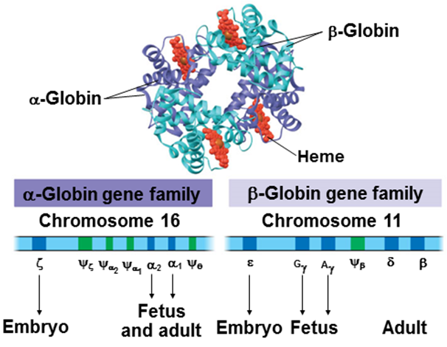

Genes Families on Different Chromosomes
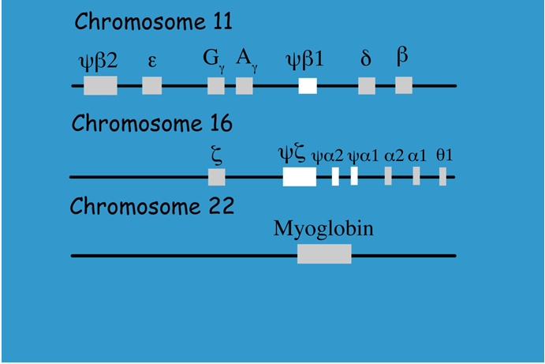

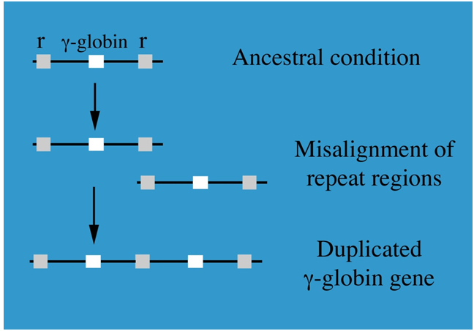
Genes Families: The misalignment of genes during recombination is the most likely cause of gene duplication and clustering. Once repeats exist the probability of misalignment increases.
Genes Families: The misalignment - Globins

Super Families: Super families are much larger than single multigene families. Super families contain hundreds of genes, including multiple multigene families and single individual genes. The large number of members allows super families to be widely dispersed with some genes clustered and some spread far apart.

LESSON 160
Type of Proteins / Families
Protein Structure: There are 20 amino acids; can be hydrophobic / hydrophilic, charged / neutral
Functions: Enzymes, Structure protein, Channel, Other functions

Amino Acids are building blocks of proteins
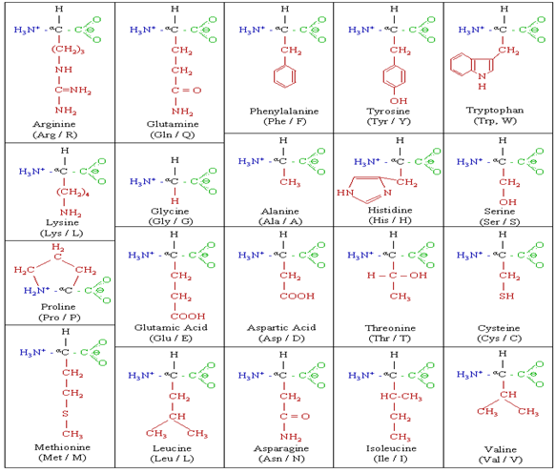

Protein Structure: Amino Acid
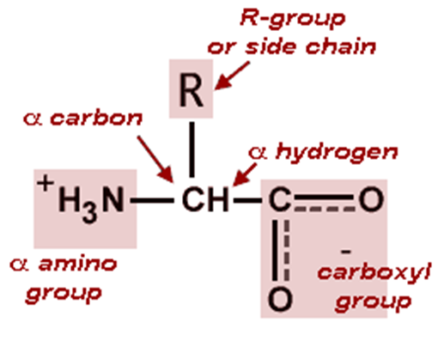

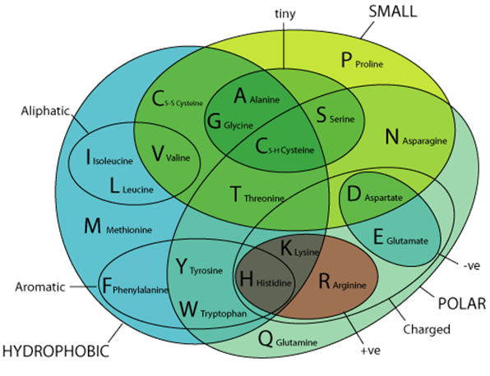
Protein Structure: Types of Amino Acids

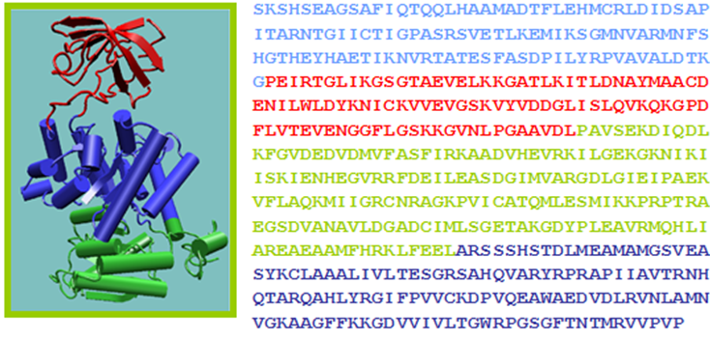
Protein Domains: Domains are units of compact structure, function and evolution and folding

Proteins: Different method of categorizing proteins. Three major categories;
- Fibrous proteins
- Globular proteins
- Complexes with multiple components including proteins

Types with selected examples
Fibrous Proteins – Cytoskeletal Proteins
- Actin
- Coronin
- Dystrophin
- Keratin
- Tubulin
Fibrous Proteins – Extracellular Matrix Proteins
- Collagen
- Elastin
- Fibronectin
Globular Proteins - Major Types
- Plasma proteins
- Hemoproteins
- Cell adhesion
- Transmembrane transport proteins
- Hormones and growth factors
- Receptors
- DNA-binding protein
- Immune system proteins
- Nutrient storage/transport
- Chaperone proteins
- Enzymes
Complexes with multiple components including proteins
- Nucleosome
- Ribonucleoprotein (generic)
- Signal recognition particle
- Spliceosome

LESSON 161
Genes Densities: How many genes are there per unit length along the genome. Many mitochondrial genomes have less than 20 genes in their entire genome. Free-living bacteria and archaea have 1,000 to 7,500 genes. Unicellular fungi have about 5,000 genes. Multicellular eukaryotes up to at least 20,000 - 40,000 genes. One million base pair length in human genome - contains on average about 10 genes. One million base pairs of bacterial DNA contains about 500 to 1000 genes. More gene density in prokaryotes - factors: Bacterial genes have no introns. Less inter-genic DNA. Neighboring genes are very close together throughout the genome. Hardly any big regions of non-coding DNA between genes.
Genes Numbers – not correlated to genome size For example, it is estimated that the nematode
C. elegans has 100 Mb and 20,000 genes, while Drosophila has 165 Mb and 13,700 genes
Vertebrate Genomes – more polypeptides due to alternative splicing Vertebrate genomes can produce more than one polypeptide per gene because of alternative splicing of RNA transcripts
Humans/Mammals - low genes densities Humans and other mammals have low gene density, or number of genes, in a given length of DNA. Eukaryotes - many introns within genes and noncoding DNA
Average Genes Densities in Different Species
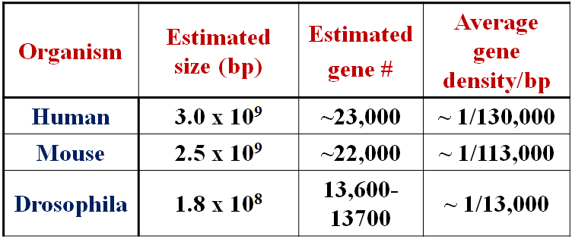

Average Genes Densities in Different Species
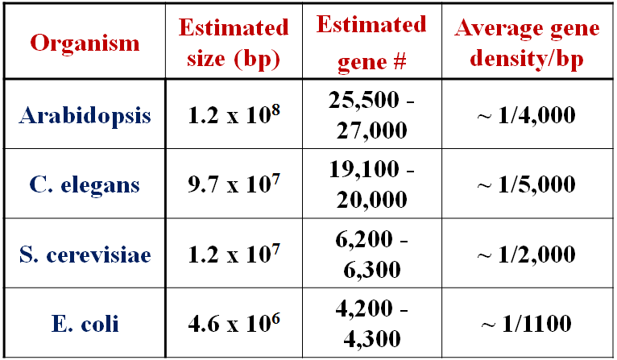

LESSON 162
Genome Evolution: Evolutionary theory predicts - organisms that are derived from a common ancestor will share genetic signatures. Organisms that shared an ancestor more recently will be more similar. Similarity can include Sequence composition, Genome organization, Presence/absence of mobile elements, Presence/absence of gene families, etc.
Genome Evolution – Chromosome 1
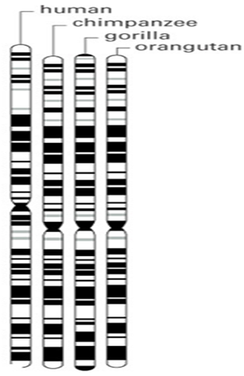

Genome Evolution: In any organism s’ lifetime; genome is Used, Damaged, Repaired, Copied and handed down to offspring cells. In the process, the genome is changed. The basis of change at the genomic level is mutation, which underlies much of genome evolution. The earliest forms of life had less number of genes - necessary for survival and reproduction. The size of genomes has increased over evolutionary time, with the extra genetic material providing raw material for gene diversification. Initially it involves just a single individual. If the change has no phenotypic consequence, it determines whether the individual’s offspring will carry the mutation or not. The process by which the frequency of mutation/allele changes in the population is called genetic drift.

Genome Evolution – Types of Changes that Contribute to Evolution
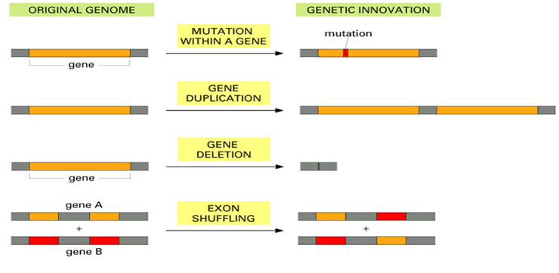

Genome Evolution – Horizontal Transfer
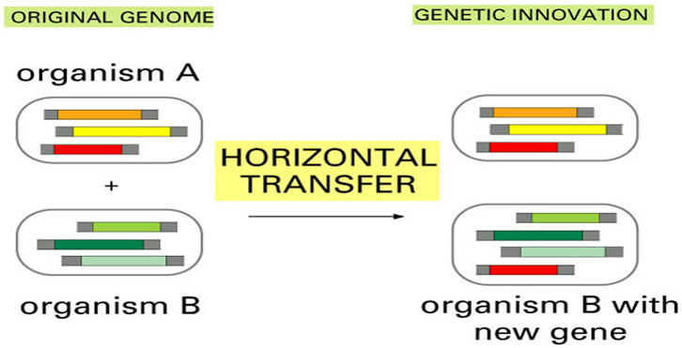

Genome Evolution: Mutations that have a beneficial effect have a larger probability of getting fixed, while deleterious mutations have almost no chance of going to fixation. Substitutions usually refer to single nucleotide substitutions, but the term “indel substitution” is also used. Accidents in meiosis can lead to one or more extra sets of chromosomes, a condition known as polyploidy

LESSON 163
Molecular Phylogenetic Analysis: Study of evolutionary relationships between genes and species. The actual pattern of evolutionary history is the phylogeny or evolutionary tree.
Molecular Phylogenetic Analysis – A tree: A tree is a mathematical structure which is used to model the actual evolutionary history of a group of sequences or organisms.
Molecular Evolution – history of genes evolution: Specifying the history of genes evolution is one of the most important aims of molecular evolution. Molecular phylogeny methods allow, from a given set of aligned sequences, phylogenetic trees which aim reconstructing the history of successive divergence/evolution. Reconstruction of phylogenetic trees is a statistical problem, and a reconstructed tree is an estimate of a true tree with a given topology and given branch length. In practice, phylogenetic analyses usually generate phylogenetic trees with accurate parts and imprecise parts.
Molecular Phylogenetic Analysis
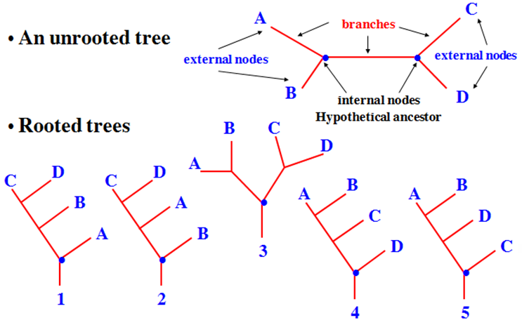

Rooted Tree: In rooted trees a single node is designated as a common ancestor, and a unique path leads from it through evolutionary time to any other node.
Unrooted Tree: Unrooted trees only specify the relationships between nodes and say nothing about the direction in which evolution occured
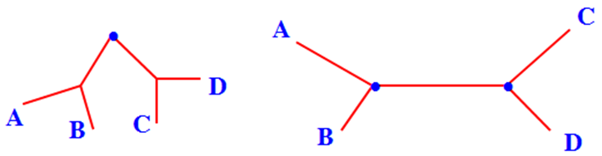
Rooted and unrooted Tree

Homologues, Orthologues, Paralogues
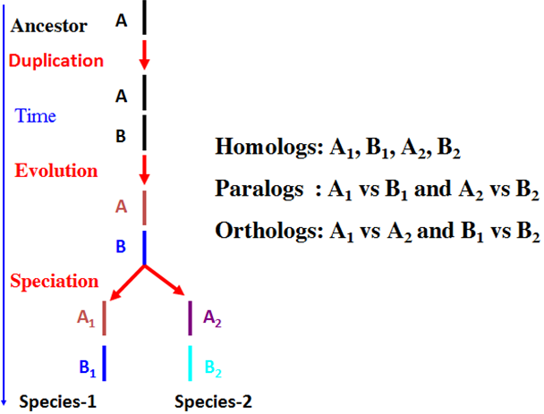

LESSON 164
Genes Tree and Species Tree: The two events - mutation and speciation- are not expected to occur at the same time. Gene trees cannot represent species tree.
Genes Tree and Species Tree
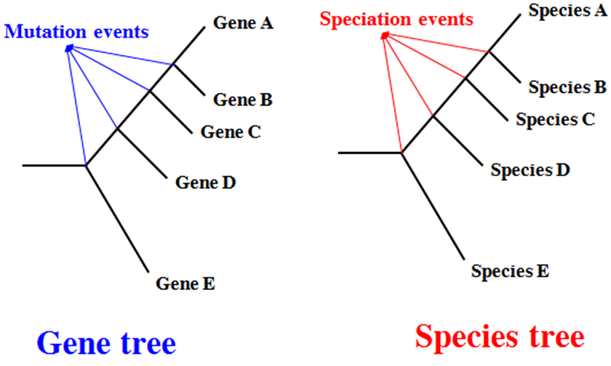

- The two events - mutation and speciation- are not expected to occur at the same time.
- Gene trees cannot represent species tree.
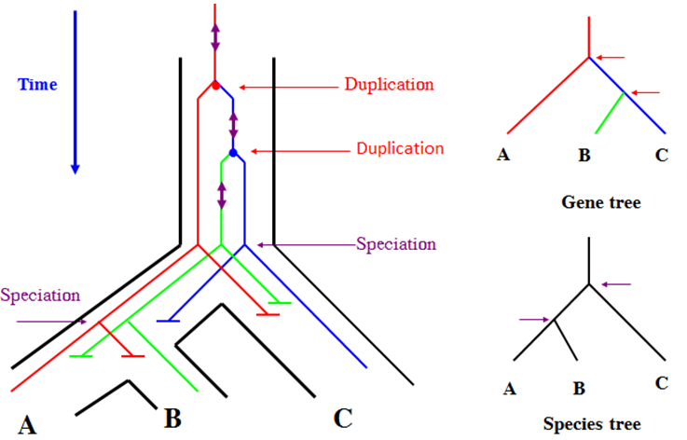

LESSON 165
Mitochondrial Genome Evolution:
- Large variation in size
- No recombination.
- Little intergenic DNA
- No introns.
- Variable control region
- Own genetic code
Ancestral Mitochondrial Genome: Reclinomonas Americana
Total of 97 genes:
  - All protein-coding genes found in all mtDNAs
  - 18 protein genes unique to Reclinomonas
  - Four genes (rpoA-D) encode a eubacteria-like RNA polymerase (α₂ββ’δ)
  - Vestigial prokaryotic operon organisation.
  - Universal genetic code
Ancestral and derived mitochondrial genomes
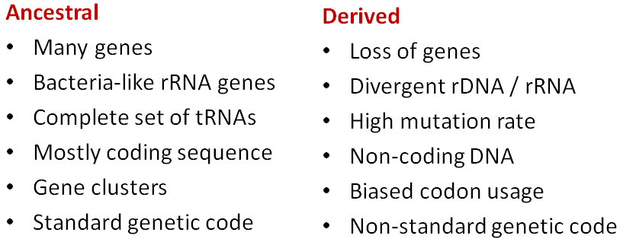

Mitochondrial Phylogeny - a separate origin for plant mtDNA: Presence of unique 5S RNA gene in plant mtDNA and structural difference led to theory of separate origin of mitochondria for plants. Analysis of mitochondrial proteins gave topology similar to nuclear gene-derived phylogenies

Mitochondrial Phylogeny
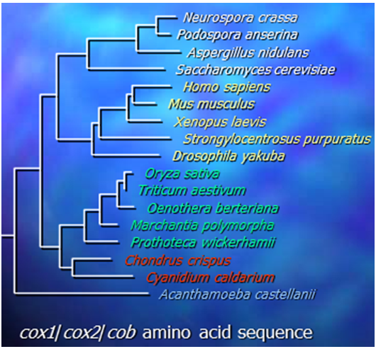

Origin of Mitochondria: Mitochondrial Phylogeny
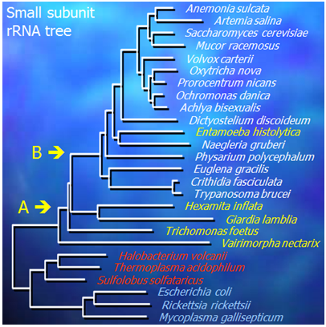

Species in yellow lack mitochondria
Entamoeba histolytica has obviously lost mitochondria
Suggests mitochondria were gained at position B
Mitochondrial Genome Evolution -

LESSON 166
Genome Evolution Nucleotides Substitutions: Two causes: damage, and copy errors during replication. More generations per unit of time - more copying errors. Rate of damage might stay constant.
Nucleotides Substitutions – Repair Mechanism: DNA errors are recognized and repaired by repair mechanisms.
Nucleotides Substitutions: In mammals, the rate of transitions (pyrimidine-to-pyrimidine or purine-to-purine) is about twice higher than the rate of transversions (pyrimidine-to-purine or vice versa).
Genome Evolution – Nucleotides Substitutions
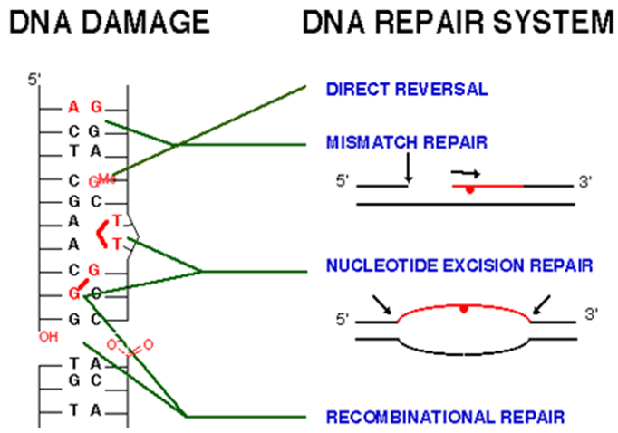

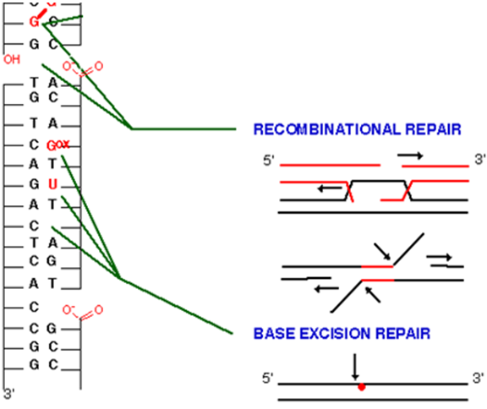

LESSON 167
Genome Evolution CpG mutations rate: In mammals, 70% to 80% of CpG cytosines are methylated. In mammalian genomes, CpG islands are typically 300bp - 3,000bp. About 70% of human promoters have a high CpG content. CpG islands typically occur at or near the transcription start site of genes. Methylation of Cytosine (mC) involves adding a methyl group (CH3) on to the C5. De-amination of the C4 carbon turns a mC into a normal Thymine.
Genome Evolution – CpG mutations rate
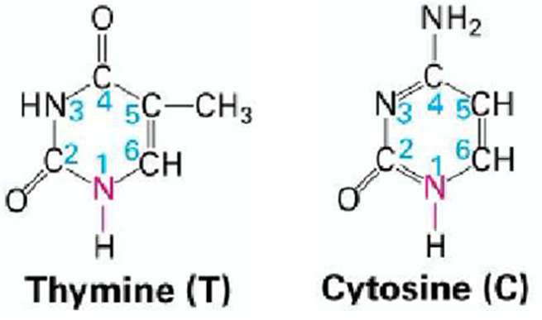

Genome Evolution – De-amination of the C4 carbon turns a methylated cytosine into a normal thymine.
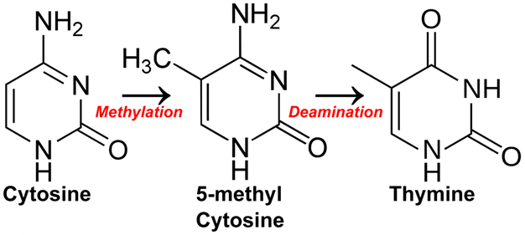

Genome Evolution – CpG mutations rate
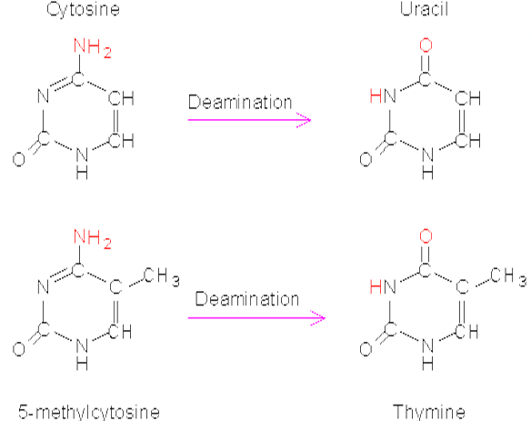

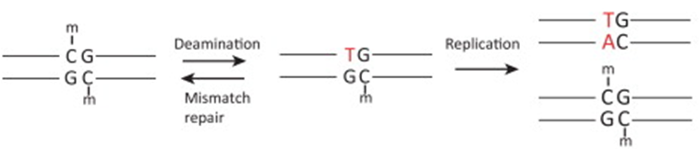
CpG mutations: Mismatch, but the wrong base cannot be identified.
CpG mutations: Genome Evolution
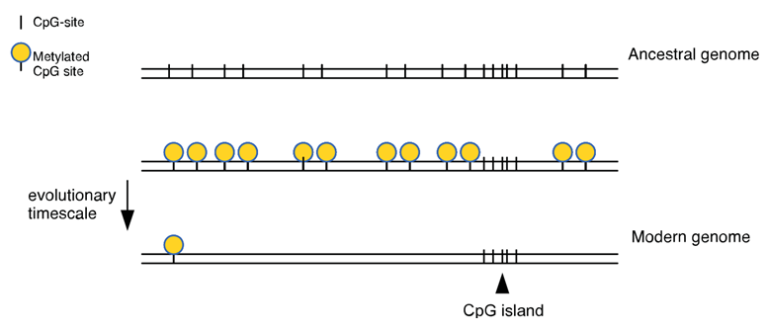

Genome Evolution – CpG mutations rate: Substitution rate on CpG dinucleotides is about 15x higher than for ordinary C’s or G’s.
Genome Evolution – CpG mutations rate –Conclusion: Methylated cytosines causes a high mutation rate. Worked as a fuel for genome evolution

LESSON 168
Genome Evolution Indels: When the ancestral sequence is not known, insertions and deletions cannot be distinguished, then referred to as “indels”. When one cannot infer the phylogenetic direction of the sequence change, the sequence change event is referred to as an "indel". A microindel is defined as an indel that results in a net change of 1 to 50 nucleotides. In coding regions of the genome, unless the length of an indel is a multiple of 3, it will produce a frameshift mutation. Rate of indels in most known genomes, including humans, tends to be markedly lower than base substitutions. Each person has 192-280 frameshifting indels. Indels form an important source of sequence change. Most small indels are in fact deletions (by a factor 3 in human). Indels can have any size, even up to several Mb. The majority are single nucleotide indels.
Genome Evolution – Indels
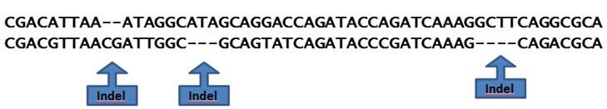

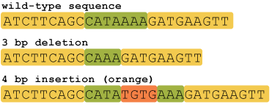

Genome Evolution – Indels in Human Genome
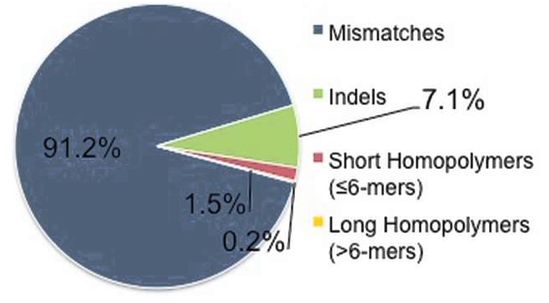

Genome Evolution – Indels: Recombination between direct repeats in a single chromosome leads to potentially large deletions.
Indels - Mostly large deletions: Recombination requires (near or same) sequence identity over fairly large region (100s nucleotides), so these deletions are mostly large.
Unequal recombinations - lead to insertions: Unequal recombination can also lead to insertions (segmental duplications).
Genome Evolution: Unequal recombination between sister chromatids at replication. Same process may also happen between parental homologous chromosomes.

LESSON 169
Genome Evolution Gene Conversions: Gene conversion = copying of one stretch
of DNA into another. Gene conversion is the process by which one DNA sequence replaces a homologous sequence such that the sequences become identical after the conversion event. Gene conversion can be either allelic, meaning that one allele of the same gene replaces another allele, or ectopic, meaning that one paralogous DNA sequence converts another. If single strand invades parental chromosome:
Without crossing over: gene conversion
With crossing over: gene conversion + recombination
Genome Evolution – Gene Conversions
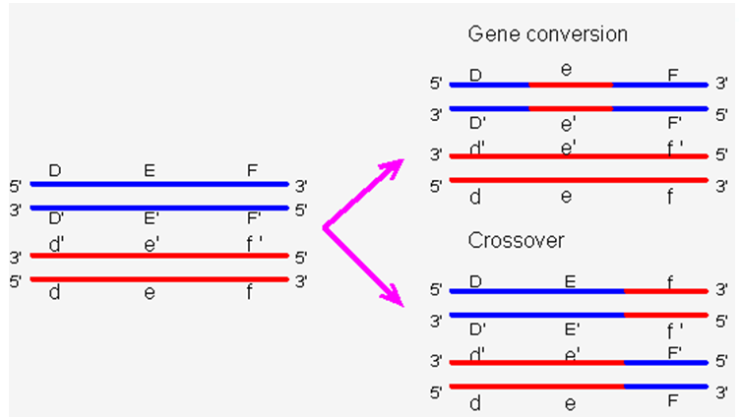

Gene Conversions – Non-allelic Genes conversion between sister chromatids or homologous chromosomes
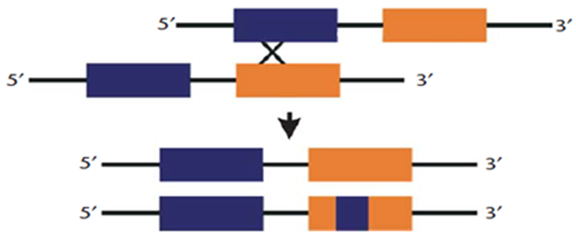

Gene Conversions between non allelic gene copies residing on same chromatics
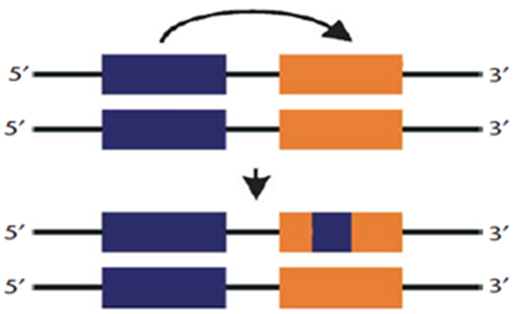

Gene Conversions: Inter-allelic gene conversion between alleles/genes residing on homologous chromosomes
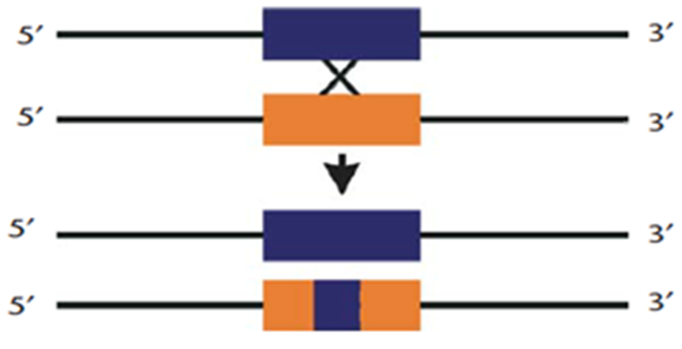

LESSON 170
Genome Evolution Gene Duplications: Slipped strand mispairing. Unequal crossover during recombination
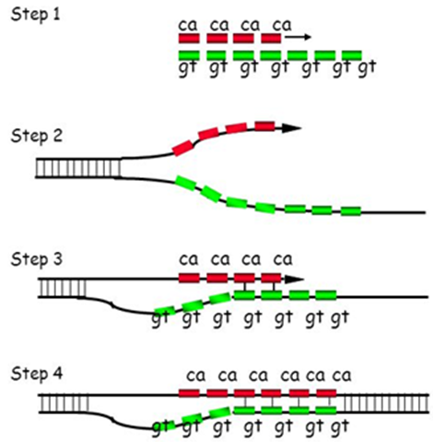
Genome Evolution – Slipped Strand Mispairing

Gene Duplications by Unequal Crossover
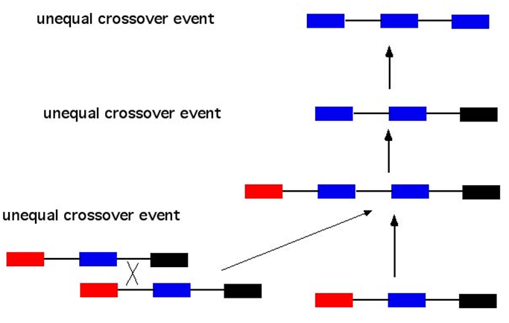

Genome Evolution – Gene Duplications
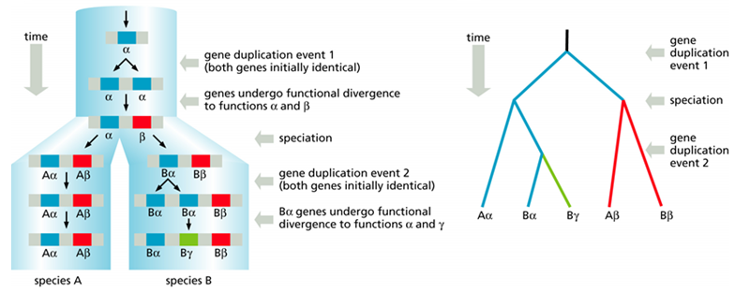

Genome Evolution – Gene Duplications: the globin family. Ancestral globin gene (present in primitive animals) was duplicated ~500 million years ago. Mutations accumulated in both genes to differentiate them - α and β present in all higher vertebrates. Further gene duplications produced alternative forms in mammals and in primates
Genome Evolution – Gene Duplications
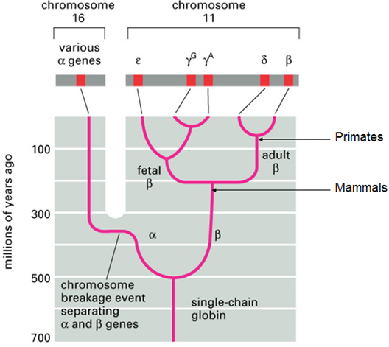

Almost every gene in the vertebrate genome exists in multiple copies. Gene duplication allows for new functions to arise. Studies suggest about early vertebrate evolution, the entire genome was duplicated at least twice

LESSON 171
Genome Evolution Exons Shuffling /Duplications: Duplications are not limited to entire genes. Proteins are often collections of distinct amino acid domains that are encoded by individual exons in a gene. The separation of exons by introns facilitates the duplication of exons and individual gene evolution
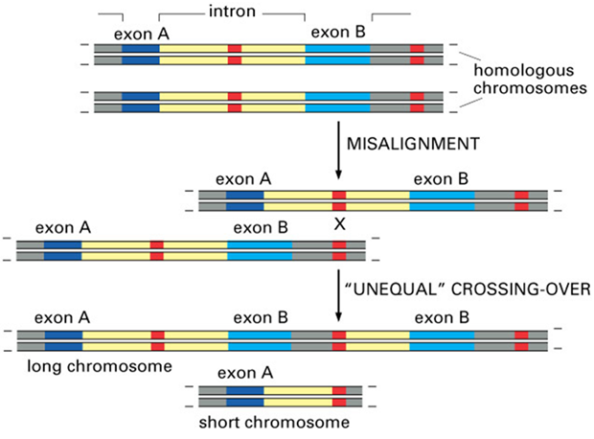

Genome Evolution – Exons Shuffling: The exons of genes can sometimes be useful units that can be mixed and matched through exon shuffling to generate new combinations/ properties of protein
Genome Evolution – Exons Shuffling
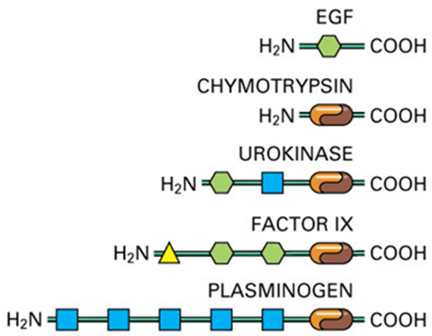

LESSON 172
Genome Evolution – Recombination Hotspots
Recombination Hotspots: Recombination hotspots are regions of genomes that exhibit elevated rates of recombination relative to a neutral expectation. Recombination hotspots are thought to arise due to higher-order chromosome structure that makes some areas of the chromosome more accessible to recombination. The peak recombination rate within hotspots can be hundreds of times that of the surrounding region. Recombination hotspots can occur through meiotic recombination or through errors in DNA replication that lead to genomic rearrangements.
Recombination Hotspots – Linkage disequilibrium: Linkage disequilibrium has identified more than 30,000 hotspots within the human genome
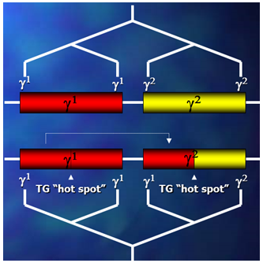
Recombination Hotspots: In humans, average number of crossover recombination events per hotspot is one crossover per 1,300 meiosis, and the most extreme hotspot frequency of one per 110 meiosis. Primate g-globin genes: Conversion occurs at TG-repeat “hot spots”Recombination hotspots do not seem to be solely caused by DNA sequence arrangements or chromosome structure. Alternatively, initiation sites of recombination hotspots can be coded for in the genome.

Recombination hotspots – Current Isochore Structure: Perhaps differences in recombination rates have, over time, caused the current isochore structure through biased gene conversion.

LESSON 173
Genome Evolution – Double Stranded Breakage: Double-strand breaks, in which both strands in the double helix are damaged. DSB can lead to genome rearrangements
Double Stranded Break Repair: Three mechanisms exist to repair DSBs:
- Non-homologous end joining (NHEJ),
- Microhomology-mediated end joining (MMEJ)
- Homologous recombination
Double Stranded Break Repair in Mammalian Cells: DSB in mammalian cells are primarily repaired by: Homologous recombination, Non-homologous end joining, Non-homologous end joining (NHEJ) pathway does not require homologous sequence. Repairs most break correctly, but are also able to induce translocations (chromosome rearrangements). Basis of genome changes and genome evolution
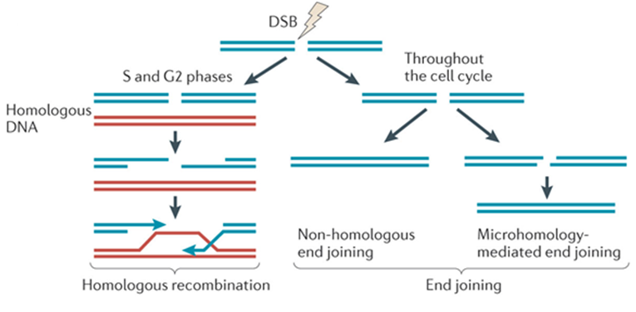
Genome Evolution-Double Stranded Break Repair

Genome Evolution: Double stranded break repair –
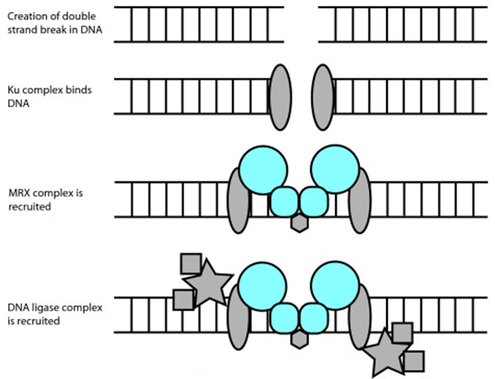

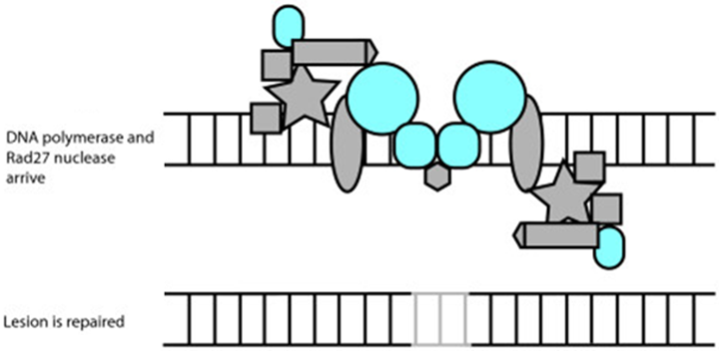

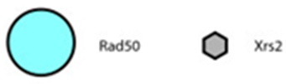
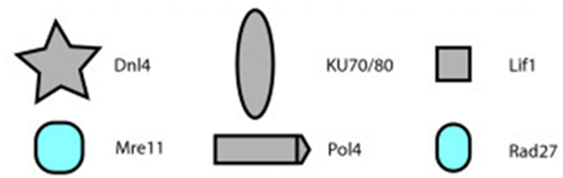
Key Players

LESSON 174
Genome Evolution Chromosomal Rearrangements: Chromosomal rearrangement is a type of chromosome abnormality involving a change in the structure of the native chromosome. Such changes may involve several different classes of events, like Deletions, Duplications, Inversion, and Translocations. Caused by a breakage in the DNA double helices at two different locations, followed by a rejoining of the broken ends to produce a new chromosomal arrangement
Chromosomal rearrangements – Some region more vulnerable: Some chromosomal regions are more prone to rearrangement than others and thus are the source of evolution
Genome Evolution – Chromosomal rearrangements: This instability is usually due to the susceptibility of these regions to misalign during DNA repair. Speciation frequently occurs when a population becomes fixed for one or more chromosomal rearrangements that reduce fitness. About 160 million years that separate humans and mice. Many chromosomal rearrangements have occurred.
Genome Evolution – Chromosomal Rearrangements
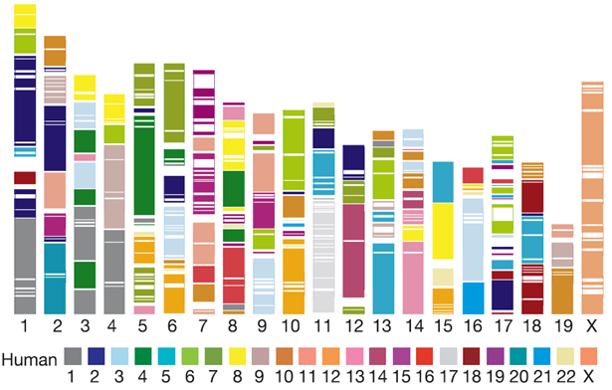

Mouse chromosomes (1-19 and X) coloured according to homology with human chromosomes (1-22 and X).
Alterations of Chromosome structure: Humans 23 pairs of chromosomes, while chimpanzee 24 pairs. Divergence of humans and chimpanzees from a common ancestor, two ancestral chromosomes fused

Genome Evolution-Alterations of Chromosome Structures
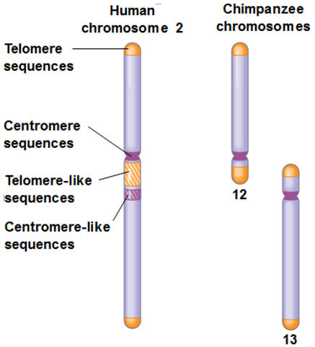

Genome Evolution – Alterations of Chromosome structure: Comparative analysis between chromosomes of humans and seven mammalian species paints a hypothetical chromosomal evolutionary history
Genome Evolution-Alterations of Chromosome structure
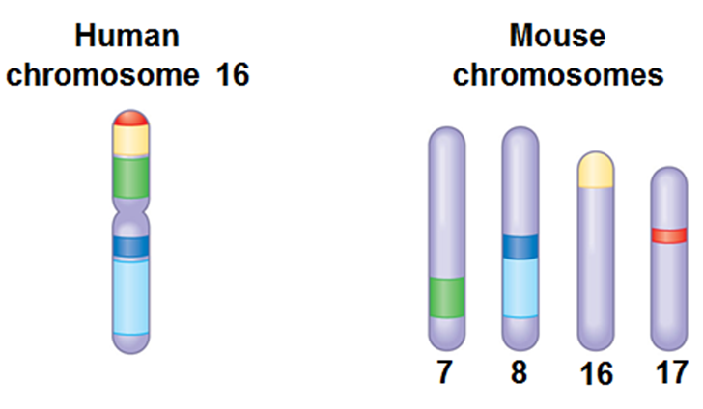

LESSON 175
Gene Expression Mechanism: Mechanism by which a gene's information is converted into the structures and functions of a cell by producing a biologically functional molecule protein or RNA. Gene expression is assumed to be controlled at various points in the sequence leading to protein synthesis.
Gene Expression Mechanism – Turn on: The product of a regulatory gene is required to initiate (turn on) the expression of one or more genes.
Gene Expression Mechanism – Turn off: The product of a regulatory gene is required to turn off the expression of one or more genes.
Gene Expression–Two Steps Process: The synthesis of mRNA uses the gene on the DNA molecule as a template. This happens in the nucleus of eukaryotes.The synthesis of a polypeptide chain using the genetic code on the mRNA molecule as its guide.
Gene Expression Mechanism – Conclusion: Mechanism by which a gene's information is converted into a biologically functional molecule (protein or RNA)

LESSON 176
Gene Expression and Genetic Switches
Gene Expression: The process by which a gene's information is converted into the structures and functions of a cell
Gene Expression and Genetic Switches
- Tryptophan Repressor = a simple on/off switch
- Repressor= protein binds to DNA to prevent transcription of adjacent gene
- Activator = protein that binds to DNA and promotes the transcription of adjacent gene
- Tryptophan Repressor = A simple on/off switch
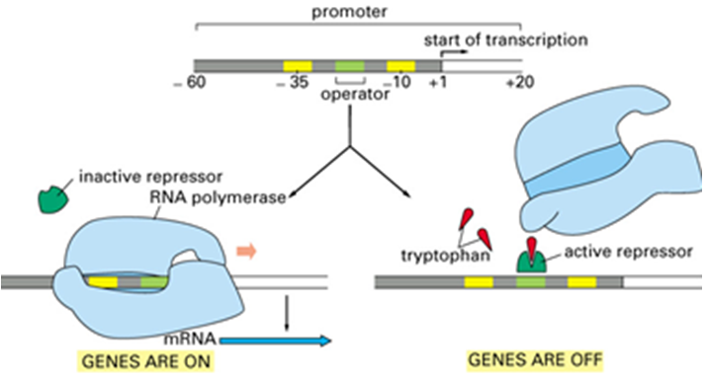

Gene Expression and Genetic Switches
Tryptophan Repressor = a simple on/off switch
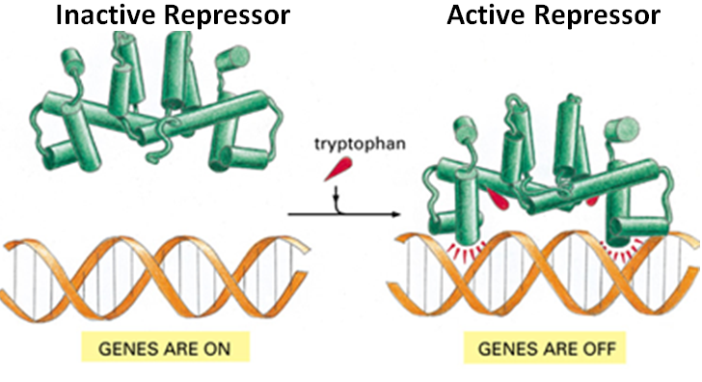

Gene Expression and Genetic Switches Catabolite Activator Protein (CAP):
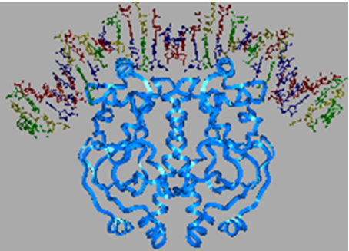

Promotes transcription of genes that enable E. coli to use alternative carbon sources when glucose is not available.
Complicated Genetic Switches: Complicated genetic switches combine positive and negative controls. Lac operon- under the control of transcriptional activator and transcriptional repressor

Lac Operon - Under the control of transcriptional activator and transcriptional repressor
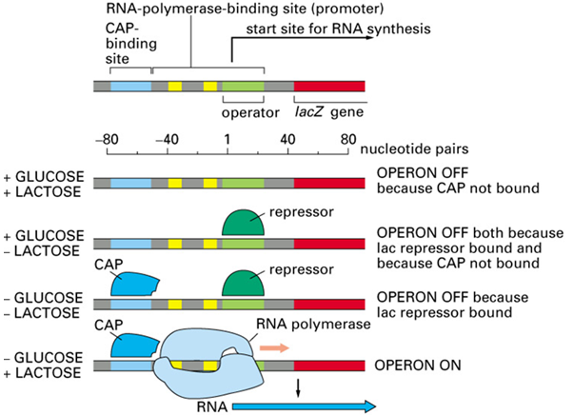

Regulation of Transcription in Eukaryotes is More Complex
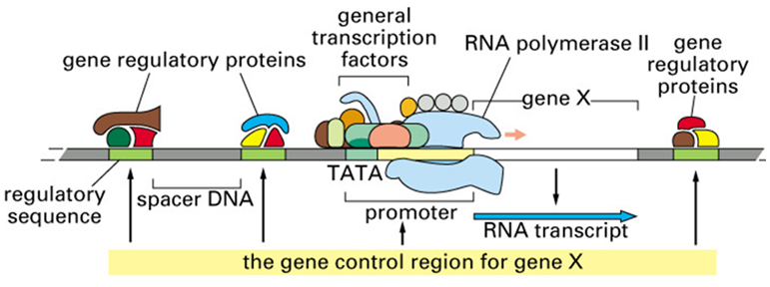
GRPs can act even when positioned 1000’s bp away from promoter. RNA Pol II cannot initiate transcription on its own, requires GTFs

Regulation of Transcription in Eukaryotes and GRPs allow genes to be turned on and off very specifically
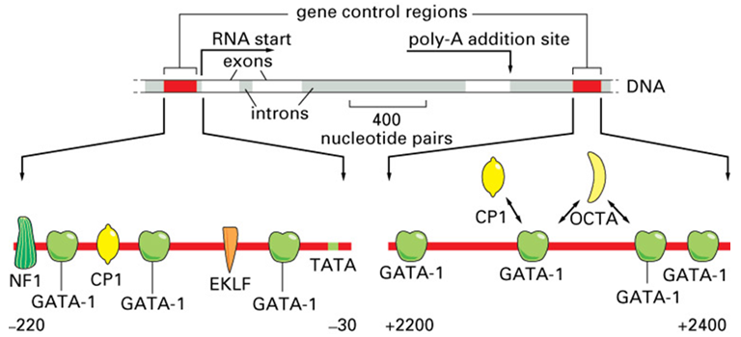

LESSON 177
Inducible and Repressible Systems: Expression of genes may be
- Constitutive
- Inducible
- Repressible
Constitutive Genes Expression: Genes that perform housekeeping functions - for example, the ribosomal RNAs and those proteins involved in protein synthesis
Non-constitutive Genes Expression: Some genes are expressed only when their products are required for growth.
Constitutive genes: Gene products (e.g., tRNAs, rRNAs, ribosomal proteins, DNA and RNA polymerase subunit, ATP and GTP) are essential components of almost all living cells.
Non-constitutive – Inducible and Repressible Genes: Gene products needed for cell growth under certain environmental conditions. Synthesis of these gene products occurs when needed
Operons: Either Inducible or Repressible
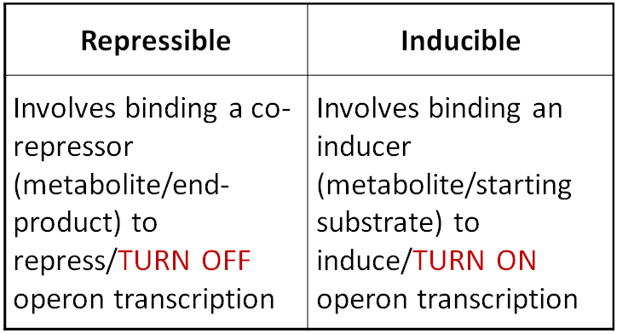

Inducible and Repressible Systems: Three combinations
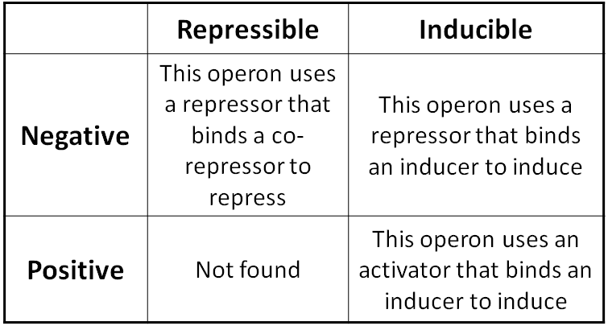

Negative Inducible Control: Absence of lactose, an active repressor protein binds to the operator and blocks transcription
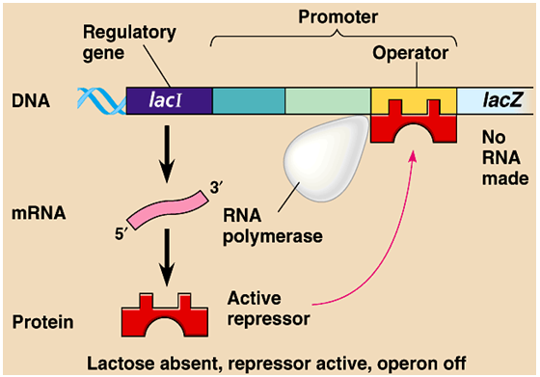

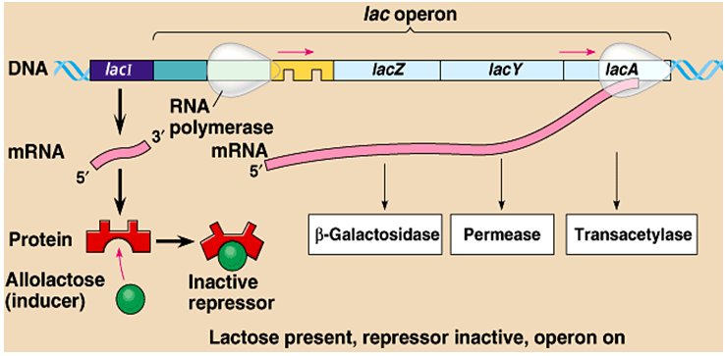
Positive Inducible Control: lactose is present in the cell, allolactose, an isomer of lactose, binds to the repressor. This inactivates the repressor, because it can no longer bind the operator.

Positive Inducible Control: If glucose levels are low (along with overall ATP energy levels), then cAMP is high. cAMP binds to CAP (a.k.a. CRP) which activates Lac operon transcription
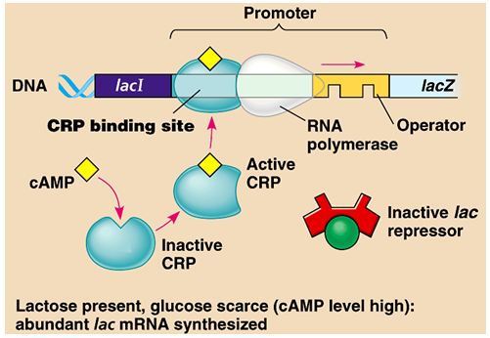

Negative Repressible Control: By itself, the operon is on. RNA polymerase can bind to the promotor and moves freely through the operator to transcribe the genes:
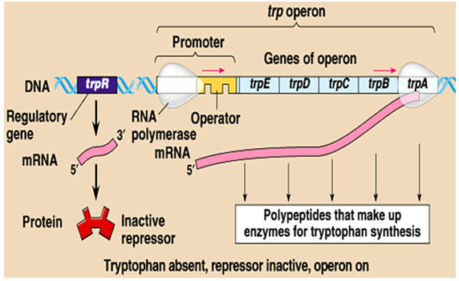

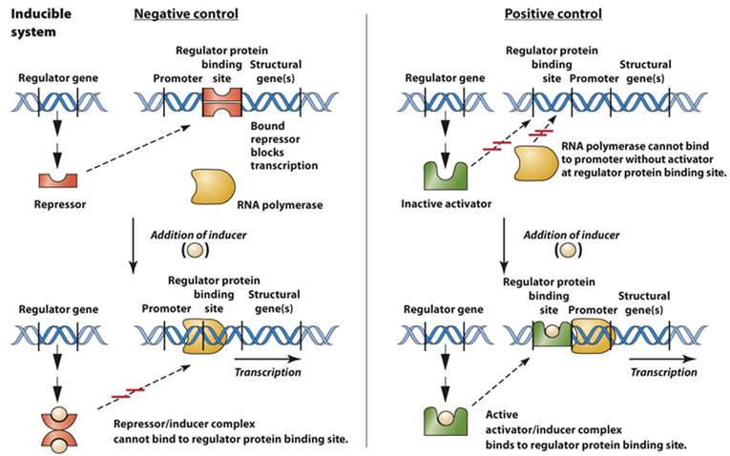
Inducible Systems

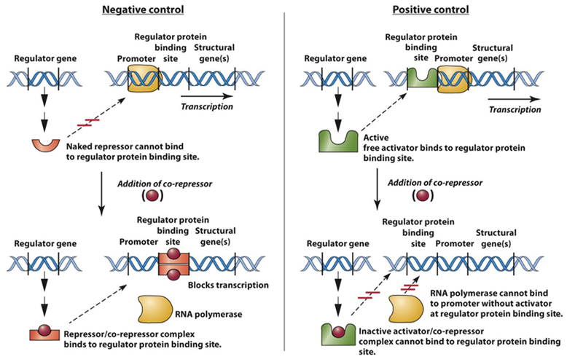
Repressible Systems

LESSON 178
Regulation of Gene Expression in Prokaryotes: Prokaryotes have operons which are functionally related genes grouped together on chromosome. Switched on or off together. Mechanisms that involve the rapid turn-on and turn-off of gene expression in response to environmental changes. Prokaryotes have preprogrammed circuits or cascades or system or pathways of gene expression. Consists of proper sequence of events. Genes for enzymes that synthesize the amino acid tryptophan. Regulatory gene makes repressor protein. Repressor is activated by binding tryptophan, and blocks transcription by binding operator. Negative feedback- shuts down operon if there is plenty of tryptophan present
Regulation of Gene Expression in Prokaryotes
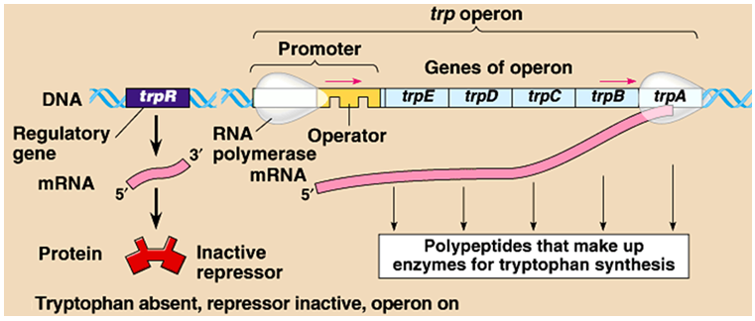

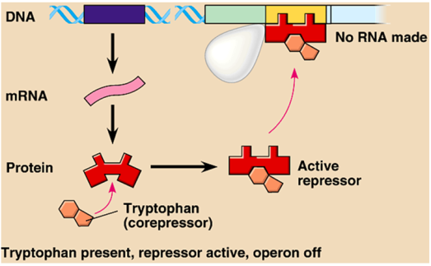

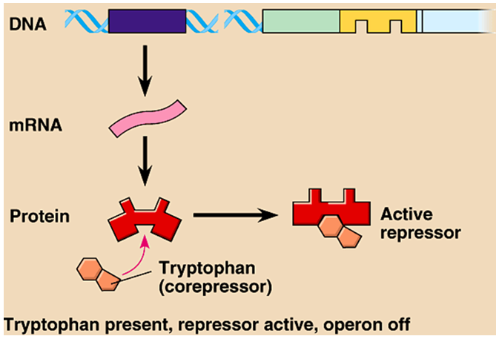

Regulation of Gene Expression: Prokaryotes have operons which are functionally related genes grouped together on chromosome. Switched on or off together

LESSON 179

Operon Model of Prokaryotes: Operon - cluster of bacterial genes along with promoter that controls the transcription of those genes. Prokaryotes - operon includes structural genes, the operator and the promoter.
Organization of a Bacterial Operon
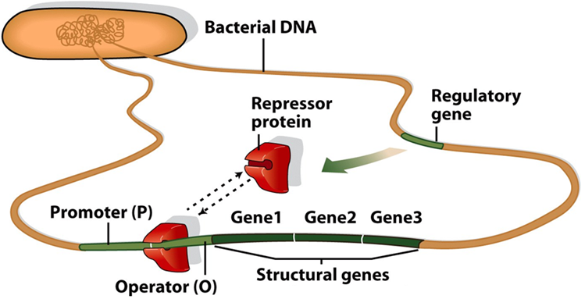

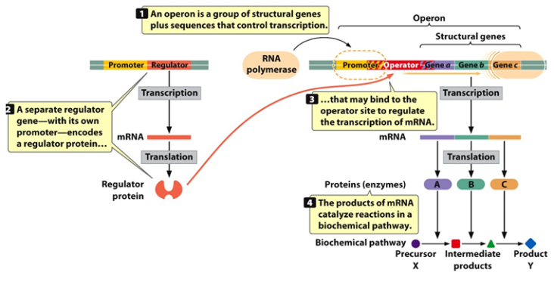

Components of Operon – Repressor: The repressor gene encodes a repressor. The repressor binds to the operator. Binding is regulated by the presence or absence of the effector molecule (inducer or co-repressor).
Components of Operon – Promoter and Operator: The promoter is the site of transcription initiation for the structural gene(s). Transcription of the structural gene(s) is regulated by binding of repressor to the operator.
Organization of a Bacterial Operon
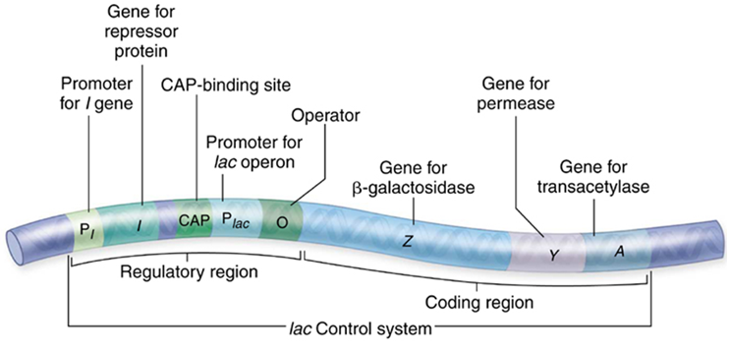

Two Types of Operons
- Inducible operons: Transcription is usually off and needs to be turned on.
- Repressible operons: Transcription is normally on and needs to be turned off.
Positive and Negative Control Mechanism: Regulator genes encode products that regulate the expression of other genes.
Positive Control Mechanism: In positive control mechanisms, the product of the regulator gene is required to turn on the expression of structural genes. In positive control systems, the regulator gene products are called activators because they activate transcription of the structural gene(s).
Negative Control Mechanism: In negative control mechanisms, the product of the regulator gene is necessary to switch off the expression of structural genes. In negative control systems, the regulator gene products are called repressors because they repress transcription of the structural gene (s).
Lac Operon Repressed
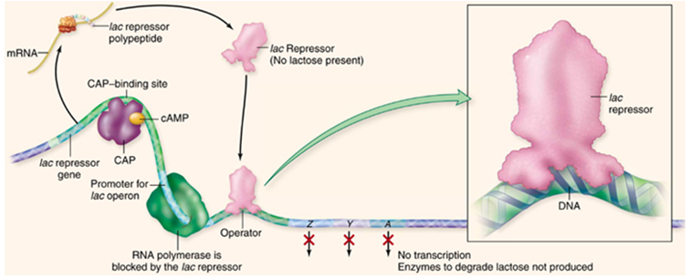

Lac Operon Induced
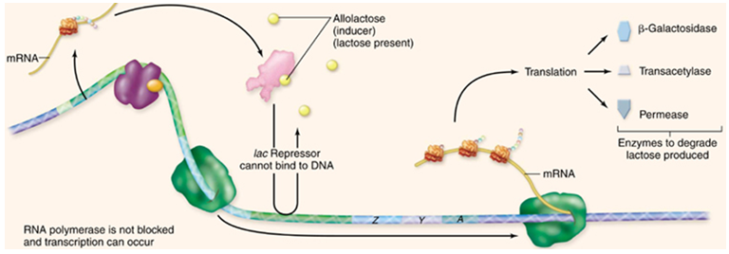

Glucose Low, Inducer Present, Promoter Activated
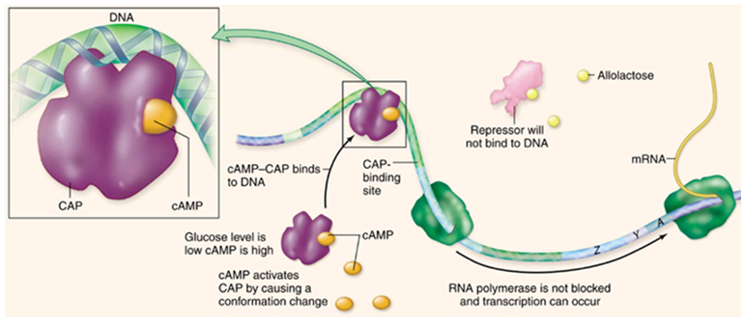

Glucose High, Inducer Absent, Promoter not activated
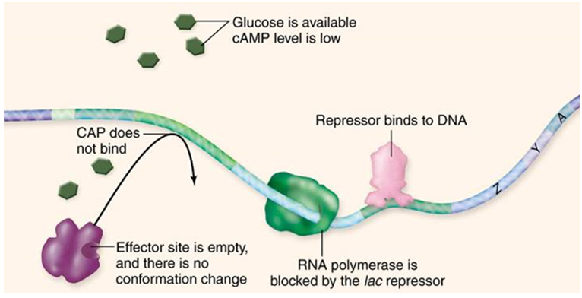

Trp Operon: The trp operon is negatively regulated by the trp repressor protein. trp repressor binds to the operator to block transcription. Binding of repressor to the operator requires a corepressor which is tryptophan. Low levels of tryptophan prevent the repressor from binding to the operator
Tryptophan Absent, Promoter Activated
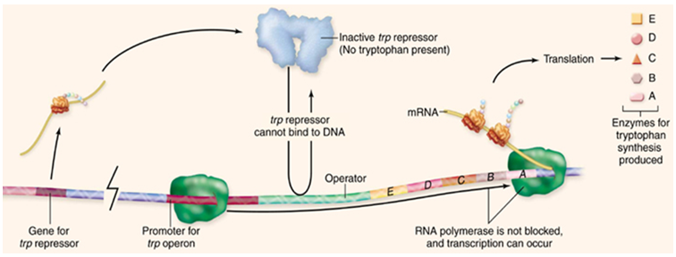

Tryptophan Present, Promoter Repressed
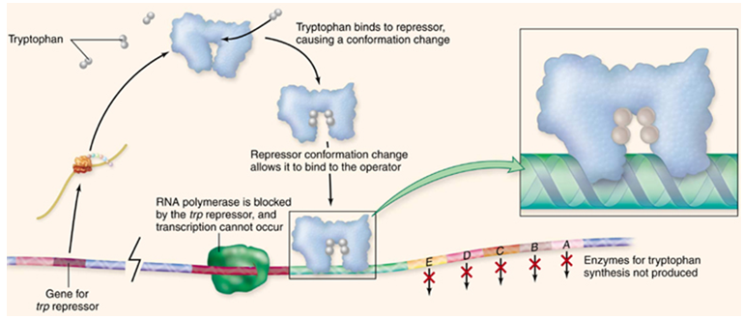

LESSON 180
Eukaryotic Gene Expression: Eukaryotic gene expression can be regulated at the
- Transcription
- RNA processing
- Translational level
- Post-translational level
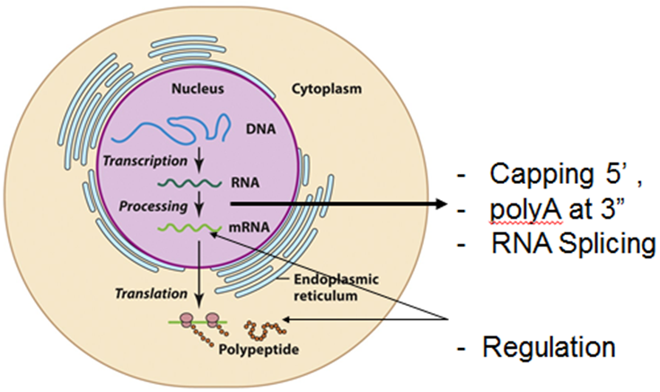

Eukaryotic Gene Expression: Both intracellular signaling and intercellular communication are important for transcriptional regulation in eukaryotes.
Eukaryotic Gene Expression – Transcription Factors: Positive and negative regulator proteins. Transcription factors bind to specific regions of DNA and stimulate or inhibit transcription.
Basal/General Transcription Factors: Basal transcription factors are proteins that bind to specific DNA sequences within the promoter to facilitate RNA polymerase alignment.
Specific Transcription Factors: Specific Transcription Factors are proteins that bind to response elements or to sequences called enhancers that are located near a gene and facilitate the action of BTF

DNA Sequences that Control Transcription
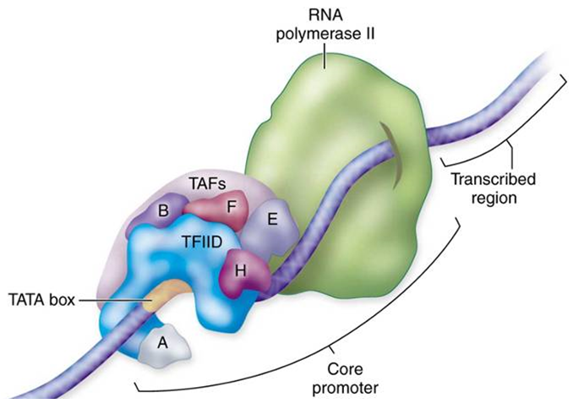

Enhancers: Enhancers act over relatively large distances. The effects of enhancers are independent of position. They may be upstream, downstream, or within an intron.
Control Elements, Enhancers, Silencer
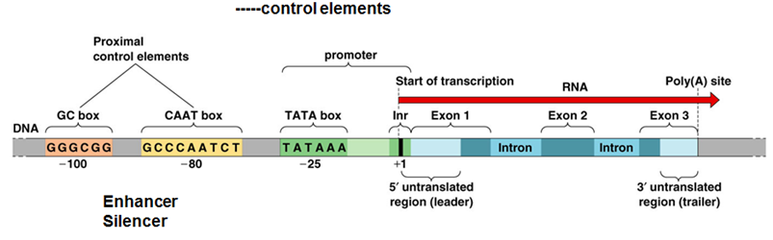
Control Elements: GTF bind to promoter region. Enhancers are DNA sequences to which STF (activators) bind to increase rate of transcription.

Control Elements: Enhancers and General Factors
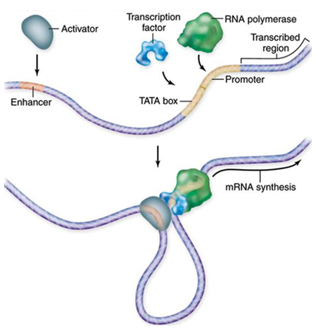

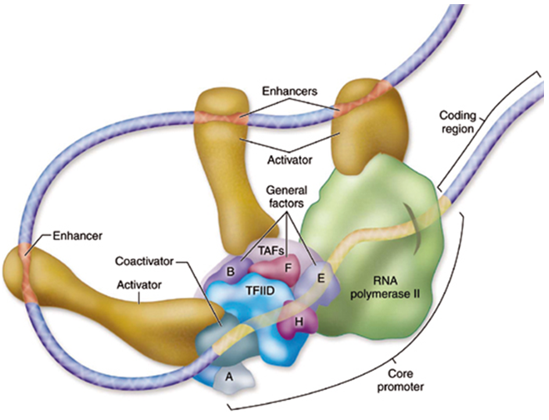

Post-transcriptional Regulation: Mostly control of gene expression at transcription. Gene expression can be controlled after transcription, with mechanisms: RNA interference/editing alternative splicing, mRNA degradation

